FACULTY OF TECHNOLOGY

course BUSINESS SYSTEMS ANALYSIS (BSA)
PROJECT REPORT ON
BUSINESS REQUIREMENTS DOCUMENT FOR B2B WHOLESALE & DISTRIBUTION (OFFICE SUPPLIES & STATIONERY): OFFICEPRO DISTRIBUTION CO., LTD.
Submitted by: | Vo Duy Binh (22301500) & Pham Nguyen Gia Thuan (22204631)
Class: 0100
Under The Guidance Of: MSc. Nguyen Thi Thanh Thanh

November 2026
FACULTY OF TECHNOLOGY
course BUSINESS SYSTEMS ANALYSIS (BSA)
PROJECT REPORT ON
BUSINESS REQUIREMENTS DOCUMENT FOR B2B WHOLESALE & DISTRIBUTION (OFFICE SUPPLIES & STATIONERY): OFFICEPRO DISTRIBUTION CO., LTD.
Submitted by: | Vo Duy Binh (22301500) & Pham Nguyen Gia Thuan (22204631)
Class: 0100
Under The Guidance Of: MSc. Nguyen Thi Thanh Thanh

November 2026

FACULTY OF TECHNOLOGY — HOA SEN UNIVERSITY

COURSE: BUSINESS SYSTEMS ANALYSIS (BSA) — ACADEMIC YEAR 2026–2027, SEMESTER 1

PROJECT REPORT ON
Project Attribute | Details
Course Domain / Enterprise Model | Scenario B — B2B Wholesale & Distribution (Office Supplies & Stationery)
Submitted by | Vo Duy Binh (Student ID: 22301500) — Team Leader / Lead Business AnalystPham Nguyen Gia Thuan (Student ID: 22204631) — QA & Requirements Analyst
Class | BA2631 — Semester 1 (2026–2027)
Under The Guidance Of | MSc. Nguyen Thi Thanh Thanh
Milestone / Assessment | Phase 1 Mid-Term Assessment (Sections 1–4 Baseline — 30% Weight)
Month, Year | October 2026

EXECUTIVE SUMMARY
OfficePro Distribution Co., Ltd. (OfficePro Distribution) is a regional B2B wholesale distributor specializing in commercial office stationery, commercial copy paper products, and printer consumables across Southern Vietnam. The enterprise currently serves over 250 active corporate clients, educational institutions, and stationery retail sub-dealers from two primary facilities: Tan Binh Central Warehouse (2,500 m²) and Bien Hoa Regional Depot (800 m²).
As the enterprise expands, it faces critical operational bottlenecks stemming from legacy paper and spreadsheet procedures:
1. Contract Price Discrepancies: Framework contract prices are decentralized across individual sales reps' personal spreadsheets, producing a 5–8% billing error rate on client invoices and costing ~50 million VND monthly in dispute adjustments.
2. Post-Confirmation Stockouts: Warehouse goods receipts take 24–48 hours to be entered into spreadsheets. Sales reps confirm delivery commitments based on outdated morning stock sheets, triggering 3–4 stockouts per week post-confirmation.
3. Manual 3-Way Matching Overhead: Accounts Receivable expends 15–20 hours weekly manually reconciling paper Sales Orders, physical Delivery Notes, and Billing Invoices, while credit hold policies are verbally bypassed.
In strict accordance with the BSA Course BRD Template, this report establishes a Pure Business Systems Analysis (Phase 1) covering:
- Section 1: Enterprise profile, 10-SKU Master Data catalog, facilities network, and team governance.
- Section 2: Stakeholder Power/Interest matrix, verified elicitation evidence, information needs, and open assumptions.
- Section 3: Five core business processes, AS-IS BPMN friction points, 5-Whys root cause analysis, TO-BE re-engineered workflows, and expected business benefits.
- Section 4: Solution-neutral Business Requirements (BR-01 to BR-05), MoSCoW Functional Requirements (FR-01 to FR-08), Core Business Rules (BR-R01 to BR-R06), and Requirements Traceability Matrix (RTM).
- Sections 5 & 6: Phase 2 roadmaps for Use Case specifications and Odoo ERP solution mapping (deferred to Weeks 8–15 per course guidelines).

TABLE OF CONTENTS
Section / Deliverable Heading | Template Page Reference
EXECUTIVE SUMMARY | i
TABLE OF CONTENTS | ii
ACKNOWLEDGEMENTS | iv
TABLE OF FIGURES | v
LIST OF TABLES | vi
GLOSSARY & ABBREVIATIONS | vii
TEAM MEMBERS & PROCESS RESPONSIBILITY MATRIX | viii
SECTION 1. ENTERPRISE CONTEXT AND SCOPE | 1
&nbsp;&nbsp;&nbsp;&nbsp;1.1. Enterprise Profile | 1
&nbsp;&nbsp;&nbsp;&nbsp;&nbsp;&nbsp;&nbsp;&nbsp;1.1.1. Business Model and Operational Overview | 1
&nbsp;&nbsp;&nbsp;&nbsp;&nbsp;&nbsp;&nbsp;&nbsp;1.1.2. Products, Services, and Target Customers | 1
&nbsp;&nbsp;&nbsp;&nbsp;&nbsp;&nbsp;&nbsp;&nbsp;1.1.3. Organizational Structure and Key Roles | 1
&nbsp;&nbsp;&nbsp;&nbsp;1.2. Business Objectives & Key Operational Challenges | 1
&nbsp;&nbsp;&nbsp;&nbsp;1.3. Enterprise Scope & Out-of-Scope Boundaries | 1
&nbsp;&nbsp;&nbsp;&nbsp;1.4. Team Member & Process Responsibility Matrix | 1
SECTION 2. STAKEHOLDER ANALYSIS & ELICITATION | 2
&nbsp;&nbsp;&nbsp;&nbsp;2.1. Stakeholder Identification & Power/Interest Grid | 2
&nbsp;&nbsp;&nbsp;&nbsp;2.2. Elicitation Summary & Verified Evidence Log (Verified Evidence vs. Initial Assumptions) | 2
&nbsp;&nbsp;&nbsp;&nbsp;2.3. Stakeholder Information Needs | 2
&nbsp;&nbsp;&nbsp;&nbsp;2.4. Assumptions, Uncertain Information & Follow-up Questions | 2
SECTION 3. BUSINESS PROCESS ANALYSIS (AS-IS & TO-BE) | 3
&nbsp;&nbsp;&nbsp;&nbsp;3.1. Business Process Overview & Process Scope | 3
&nbsp;&nbsp;&nbsp;&nbsp;3.2. Current Business Processes (AS-IS BPMN/Swimlane Models) | 3
&nbsp;&nbsp;&nbsp;&nbsp;&nbsp;&nbsp;&nbsp;&nbsp;3.2.1. Business Process 1: Processing Customer Orders | 3
&nbsp;&nbsp;&nbsp;&nbsp;&nbsp;&nbsp;&nbsp;&nbsp;3.2.2. Business Process 2: Checking Product Availability | 3
&nbsp;&nbsp;&nbsp;&nbsp;&nbsp;&nbsp;&nbsp;&nbsp;3.2.3. Business Process 3: Reviewing Replenishment Needs | 3
&nbsp;&nbsp;&nbsp;&nbsp;3.3. Process Problems, Bottlenecks & Root Cause Analysis | 3
&nbsp;&nbsp;&nbsp;&nbsp;3.4. Proposed Business Processes (TO-BE BPMN / Swimlane Models) | 3
&nbsp;&nbsp;&nbsp;&nbsp;3.5. Expected Process Improvements & Business Benefits | 3
SECTION 4. BUSINESS AND FUNCTIONAL REQUIREMENTS | 4
&nbsp;&nbsp;&nbsp;&nbsp;4.1. Business Requirements (BRs) | 4
&nbsp;&nbsp;&nbsp;&nbsp;4.2. Functional Requirements (FRs) | 4
&nbsp;&nbsp;&nbsp;&nbsp;4.3. Business Rules & Operational Constraints | 4
&nbsp;&nbsp;&nbsp;&nbsp;4.4. Requirements Traceability Matrix | 4
SECTION 5. USE CASE ANALYSIS | 5
&nbsp;&nbsp;&nbsp;&nbsp;5.1. Enterprise Use Case Diagram | 5
&nbsp;&nbsp;&nbsp;&nbsp;5.2. Use Case Identification & Catalog | 5
&nbsp;&nbsp;&nbsp;&nbsp;5.3. Detailed Use Case Specifications | 5
&nbsp;&nbsp;&nbsp;&nbsp;5.4. Use Case Validation & Alignment with Functional Requirements | 5
SECTION 6. ODOO-BASED SOLUTION DESIGN AND VALIDATION | 6
&nbsp;&nbsp;&nbsp;&nbsp;6.1. Proposed Solution Scope & Odoo Application Mapping | 6
&nbsp;&nbsp;&nbsp;&nbsp;6.2. Mapping Business Processes and Requirements to Odoo Workflows | 6
&nbsp;&nbsp;&nbsp;&nbsp;6.3. Odoo Configuration and Master Data Setup | 6
&nbsp;&nbsp;&nbsp;&nbsp;6.4. End-to-End Scenario Demonstration & Test Cases | 6
&nbsp;&nbsp;&nbsp;&nbsp;6.5. Requirements Coverage, Gaps & Workarounds | 6
CONCLUSION & LESSONS LEARNED | 7
&nbsp;&nbsp;&nbsp;&nbsp;Summary of Proposed Business Value | 7
&nbsp;&nbsp;&nbsp;&nbsp;Team Reflection & Individual Lessons Learned | 7
REFERENCES | 8
APPENDICES | 9
&nbsp;&nbsp;&nbsp;&nbsp;Appendix A. Raw Elicitation Notes / Evidence | 9
&nbsp;&nbsp;&nbsp;&nbsp;Appendix B. Individual Contribution Sign-off | 9

ACKNOWLEDGEMENTS
The project team would like to express our deepest gratitude to MSc. Nguyen Thi Thanh Thanh for her invaluable academic guidance, structured lectures, and continuous mentoring throughout the Business Systems Analysis course at Hoa Sen University. Her feedback during weekly workshops has been instrumental in shaping our understanding of enterprise process re-engineering and solution-neutral requirements engineering.

TABLE OF FIGURES
- Figure 1.1: Organizational Hierarchy & Operational Departmental Structure
- Figure 2.1: Stakeholder Power/Interest Matrix (2x2 Grid)
- Figure 3.1: Five Core Business Processes Integration Relationship Map
- Figure 3.2: AS-IS Cross-Functional Swimlane BPMN Diagram — Current Order Fulfillment
- Figure 3.3: TO-BE Cross-Functional Swimlane BPMN Diagram — Automated Order Fulfillment
- Figure 5.1: Enterprise Use Case Diagram — OfficePro Distribution ERP Architecture
- Figure 6.1: Odoo ERP Main Operations Dashboard — OfficePro Distribution Co., Ltd.
- Figure 6.2: End-to-End TO-BE Transaction Workflow Mapped to Odoo ERP Modules
- Figure 6.3: Master Data Configuration for Flagship SKU ST-001 (Double A 70gsm)
- Figure 6.4: 10-SKU Master Catalog in Odoo Inventory Management Module
- Figure 6.5: B2B Framework Contract Pricelist Configuration (65k Fixed Rule)
- Figure 6.6: B2B Corporate Customer Master Profile Configured with Net 30 Terms
- Figure 6.7: Live Quotation S00001 with Automated Contract Price Application
- Figure 6.8: Real-Time Available-to-Promise (ATP) Inventory Forecast Warning
- Figure 6.9: Confirmed Sales Order S00001 with Direct Warehouse Delivery Link
- Figure 6.10: Generated Warehouse Delivery Order WH/OUT/00001
- Figure 6.11: Commercial VAT Electronic Invoice INV/2026/00001 in Posted State
- Figure 7.1: Enterprise ERP Implementation & Phased Rollout Roadmap

LIST OF TABLES
- Table G.1: Glossary of Key Business Systems Analysis & Wholesale Terms
- Table 0.1: Team Members & Process Responsibility RACI Matrix (with Workload Share & Performance Rating)
- Table 1.1: Master Data Scope — 10 Primary SKUs & Standard vs. Contract Price Catalog
- Table 1.2: Individual Module Ownership Matrix & Workload Performance
- Table 1.2.1: Phase 1 Milestone RACI Assignment Matrix & Governance (Aligned 1:1 with Slide 12)
- Table 2.1: Elicitation Verification Log (Baseline Assumptions vs. Interview Evidence)
- Table 2.2: Cross-Functional Stakeholder Information Needs Matrix
- Table 2.3: Assumptions, Uncertain Information & Follow-up Tracking Log
- Table 3.1: Selected Core Business Process Metadata & Operational Boundary
- Table 3.2: Process Operational Scope (In-Scope vs. Out-of-Scope)
- Table 3.3: Inter-Process Handoffs, Transferred Artifacts & Verification Status
- Table 3.4: Sequential Step Breakdown of AS-IS Order Fulfillment Process
- Table 3.4.1: AS-IS BPMN Swimlane Step-by-Step Specification (Aligned 1:1 with Slide 12)
- Table 3.5: Field Elicitation Evidence Register
- Table 3.6: Identified Operational Problems, Root Causes, and Business Impact
- Table 3.7: 5-Whys Root Cause Analysis Breakdown by Core Problem
- Table 3.8: Key Operational Changes from AS-IS to TO-BE
- Table 3.8.1: TO-BE BPMN Swimlane Step-by-Step Specification (Aligned 1:1 with Slide 16)
- Table 3.9: Expected Process Improvements and Justified Business Benefits
- Table 4.1: Formal Business Requirements (BR-01 through BR-05)
- Table 4.2: Prioritized Functional Requirements Catalog (FR-01 to FR-08) with Verification Ideas
- Table 4.3: Core Enterprise Business Rules Matrix
- Table 4.4: End-to-End Requirements Traceability Matrix (RTM)
- Table 5.1: Enterprise Use Case Catalog & Operational Boundary
- Table 5.2: Detailed Use Case Specification — UC-SALES-01 (Apply Contract Pricing)
- Table 5.3: Detailed Use Case Specification — UC-SALES-02 (Multi-Hub ATP Query)
- Table 5.4: Detailed Use Case Specification — UC-ACC-02 (Enforce Hard Credit Lock)
- Table 5.5: Detailed Use Case Specification — UC-PURCH-01 (Automated Reorder Trigger)
- Table 5.6: Detailed Use Case Specification — UC-ACC-01 (Automated 3-Way Match)
- Table 5.7: Detailed Use Case Specification — UC-INV-02 (Bin-Guided Picking & Barcode Verification)
- Table 5.8: Use Case to Requirements & Business Rules Traceability Matrix
- Table 6.1: Master Data Scope — 10 Primary SKUs Configured in Odoo
- Table 6.2: Formal UAT Test Suite Specification (TC-01 through TC-08)
- Table 6.3: Executed User Acceptance Testing (UAT) Log — Group 6 Verification
- Table 6.4: System Capability Fit-Gap Analysis & Workaround Strategies
- Table 7.1: Operational Transformation Summary (AS-IS Baseline vs. TO-BE Validated Outcome)
- Table B.1: Master Individual Contribution Sign-off, Performance Rating & Academic Integrity Confirmation
- Table C.1: UAT Peer Review Log & Verification Audit Trail
- Table D.1: Complete Master Data Import Specification for Odoo ERP (10 SKUs)

GLOSSARY & ABBREVIATIONS
Table G.1: Glossary of Key Business Systems Analysis & Wholesale Terms
Abbreviation / Term | Full Name / Definition
ATP | Available-to-Promise Inventory (On-hand stock minus hard reservations plus scheduled inbound receipts)
B2B | Business-to-Business Wholesale Commerce
BPMN | Business Process Model and Notation (Standard visual cross-functional modeling notation)
BR | Business Requirement (High-level business capability or outcome statement)
BRD | Business Requirements Document
FR | Functional Requirement (System behavior specification: The system shall...)
Framework Agreement | Annual commercial contract governing negotiated price tiers, lead times, and Net 30 terms
MoSCoW | Prioritization Framework (Must have, Should have, Could have, Won't have)
PO | Purchase Order (Issued by OfficePro to upstream manufacturers)
RACI | Responsible, Accountable, Consulted, Informed Governance Matrix
RFQ | Request for Quotation (Supplier price solicitation)
RTM | Requirements Traceability Matrix
SKU | Stock Keeping Unit (Unique product identification code)
SO | Sales Order (Commercial delivery commitment issued to corporate accounts)
UoM | Unit of Measure

TEAM MEMBERS & PROCESS RESPONSIBILITY MATRIX
(R - Responsible | A - Accountable | C - Consulted | I - Informed)
Table 0.1: Team Members & Process Responsibility RACI Matrix (with Workload Share & Performance Rating)
Student Name | Student ID | Assigned Core Business Processes | Role in Project | Governance RACI Status | Workload Share (%) | Individual Performance Rating
Vo Duy Binh | 22301500 | BP1: Processing Customer Orders<br/>BP2: Verifying Contract Prices<br/>BP4: Reviewing Replenishment Needs | Team Leader / Lead Business Analyst | A / R (Sales & Purchasing Domains, Master BRD) | 50% | 100% (Outstanding)
Pham Nguyen Gia Thuan | 22204631 | BP3: Checking Product Availability (ATP)<br/>BP5: Receiving Goods & Inspection<br/>BP-INV: Invoicing Reconciliation | QA & Requirements Analyst | A / R (Inventory & Invoicing Domains, Quality Assurance) | 50% | 100% (Outstanding)

Detailed Phase 1 Deliverable Responsibilities:
- Vo Duy Binh (Team Leader / Lead BA):
- Section 1: Enterprise Profile, Case Background, Scope Boundaries, and RACI Governance.
- Section 2: AI Stakeholder Elicitation (Sales Manager & Purchasing Manager interviews), Open Assumptions Log.
- Section 3: Process Relationship Map, AS-IS BPMN for BP1 & BP4, 5-Whys Root Cause Analysis, TO-BE Re-engineering Design, Master BRD Compilation.
- Section 4: Business Requirements (BR-01, BR-04), Business Rules (BR-R01 to BR-R03), Traceability Matrix.
- Pham Nguyen Gia Thuan (QA & Requirements Analyst):
- Section 1: Facilities Network Definition and 10 SKUs Master Data catalog review.
- Section 2: AI Stakeholder Elicitation (Warehouse Keeper & Chief Accountant interviews), Cross-Functional Information Needs Matrix.
- Section 3: AS-IS BPMN for BP3 & BP5, AS-IS vs. TO-BE Operational Comparison Table.
- Section 4: Business Requirements (BR-02, BR-03, BR-05), MoSCoW Functional Requirements Catalog (FR-01 to FR-08), Business Rules (BR-R04 to BR-R06), QA Review.

SECTION 1. ENTERPRISE CONTEXT AND SCOPE

1.1. Enterprise Profile

1.1.1. Business Model and Operational Overview
OfficePro Distribution Co., Ltd. is a specialized regional B2B wholesale distributor operating across Southern Vietnam (Ho Chi Minh City, Dong Nai, Binh Duong, and surrounding industrial manufacturing corridors). The company bridges upstream stationery manufacturers and downstream commercial consumers, supplying over 250 active corporate accounts, higher education institutions, and stationery retail sub-dealers.
The wholesale operational model is built upon three structural pillars:
1. High-Volume Upstream Procurement: OfficePro purchases commercial stationery, copy paper products, and printer consumables in bulk pallets directly from certified manufacturers including Double A (Thailand/Vietnam), IK Plus (APP Indonesia), Thien Long Group, Pilot Corporation, and HP Vietnam.
2. Annual Framework Agreements: High-volume commercial accounts execute annual agreements establishing fixed contracted discount tiers, guaranteed replenishment lead times, and negotiated credit privileges.
3. Commercial Credit Policy: Qualified corporate accounts operate under standard Net 30-day commercial payment terms, allowing monthly consolidated billing against verified delivery notes.

1.1.2. Products, Services, and Target Customers

1. Master Data Scope: 10 Primary SKUs
To ground requirements engineering in concrete wholesale realities, OfficePro's core catalog comprises 10 primary SKUs across four product categories:
Table 1.1: Master Data Scope — 10 Primary SKUs & Standard vs. Contract Price Catalog
No. | SKU Code | Product Description | Category | UoM | Standard List Price (VND) | Contract Price Tier (VND)
1 | ST-001 | A4 Copy Paper Double A 70gsm (500 sheets/ream) | Paper Products | Ream | 75,000 | 65,000
2 | ST-002 | A4 Copy Paper IK Plus 80gsm (500 sheets/ream) | Paper Products | Ream | 85,000 | 75,000
3 | ST-003 | Thien Long TL-027 Blue Ballpoint Pen (Box of 20) | Writing Instruments | Box | 90,000 | 80,000
4 | ST-004 | Pilot G2 Black Gel Pen 0.7mm (Box of 12) | Writing Instruments | Box | 320,000 | 290,000
5 | ST-005 | King Jim A4 Display Book 60 Pockets | Filing Supplies | Piece | 45,000 | 38,000
6 | ST-006 | Deli A5 Spiral Notebook 160 Pages | Filing Supplies | Piece | 35,000 | 29,000
7 | ST-007 | Kangaro HD-10 Heavy Duty Stapler | Office Tools | Piece | 28,000 | 24,000
8 | ST-008 | Kangaro No.10 Staples (Box of 20 small packs) | Office Tools | Big Box | 42,000 | 36,000
9 | ST-009 | Original HP 107a Black Laser Toner Cartridge | Printer Consumables | Box | 1,150,000 | 1,050,000
10 | ST-010 | Pentel WB1 Whiteboard Marker (Box of 12) | Writing Instruments | Box | 180,000 | 155,000

Note on B2B Pricing Logic: In wholesale distribution, legal framework agreements guarantee discounted price tiers. For fast-mover ST-001 Double A Paper, the standard retail list price is 75,000 VND/ream, but corporate contract clients are legally billed at 65,000 VND/ream. Ensuring that systems automatically enforce this 65,000 VND rate upon customer selection is essential to eliminating invoice disputes.

2. Target Customer Segments
1. Corporate Enterprise Accounts (60% of Revenue): Commercial offices, multinational corporations, and banks ordering monthly consolidated shipments. Governed by framework contracts, custom pricing tiers, and Net 30 payment terms.
2. Educational Institutions (25% of Revenue): Universities, vocational colleges, and international schools placing large seasonal batch orders prior to academic semesters. Disbursements tied to formal state/institutional invoice approval cycles.
3. Stationery Sub-Dealers & Retailers (15% of Revenue): Small local retail stationery stores purchasing medium reorder volumes under tiered wholesale quantity discounts.

1.1.3. Organizational Structure and Key Roles
┌────────────────────────┐
│ Board of Directors │
│ / Business Owner │
└───────────┬────────────┘
│
┌───────────────────────┼───────────────────────┐
│ │ │
┌────────┴────────┐ ┌────────┴────────┐ ┌────────┴────────┐
│ Sales Dept │ │Purchasing Dept │ │ Warehouse Dept │
│ (Sales Manager │ │ (Procurement │ │(Warehouse Keeper│
│ & B2B Reps) │ │ Officer) │ │ & Dispatchers) │
└─────────────────┘ └─────────────────┘ └─────────────────┘
│
┌────────┴────────┐
│ Accounting Dept │
│(Chief Accountant│
│ & AR Officers) │
└─────────────────┘
Figure 1.1: Organizational Hierarchy & Operational Departmental Structure
- Executive Leadership (Business Owner): Oversees strategic growth, operating margins, capital allocation, and client retention.
- Sales Department (Sales Manager & B2B Reps): Manages corporate client framework contracts, negotiates pricing tiers, issues quotations, and inputs Sales Orders.
- Purchasing Department (Procurement Manager): Monitors inventory depletion, solicits supplier RFQs, compares vendor costs/lead-times, and issues Purchase Orders.
- Warehouse & Logistics Department (Warehouse Keeper & Logistics Staff): Manages inbound receiving inspection, pallet storage, bin picking/packing, and delivery handoffs.
- Finance & Accounting Department (Chief Accountant & AR Accountants): Validates 3-way invoice matching, monitors customer credit limits, issues VAT electronic invoices, and enforces Net 30 debt collection.

Facilities Network & Operational Hubs
- Corporate Headquarters & Commercial Office: District 3, Ho Chi Minh City. Houses Executive Leadership, B2B Account Representatives, Procurement Officers, and Finance & Accounting.
- Central Distribution Warehouse (Tan Binh IP, HCMC): Total floor area: 2,500 m². Stores 80% of palletized stock (paper pallets, toner cartridges). Functions as the primary supplier receiving dock and cross-docking terminal.
- Regional Transit Depot (Bien Hoa 2 IP, Dong Nai): Total floor area: 800 m². Maintains fast-moving stock to execute same-day deliveries to manufacturing enterprises across Dong Nai and Binh Duong industrial parks.

1.2. Business Objectives & Key Operational Challenges

Quantified Business Objectives
- Eliminate Contract Pricing Errors: Reduce quotation pricing error rates from 5–8% down to 0%.
- Eliminate Post-Confirmation Stockouts: Decrease post-confirmation order cancellations by 95% via real-time Available-to-Promise (ATP) stock visibility.
- Enforce Commercial Credit Compliance: Enforce 100% automated credit locks on accounts with unpaid balances overdue > 30 days.
- Accelerate Financial Matching: Reduce accounting 3-way invoice matching duration by 90%, dropping from 15–20 hours/week down to 2 hours/week.

Primary Operational Challenges
1. Contract Price Discrepancies: Decentralized Excel price sheets cause reps to copy incorrect rates, triggering billing disputes and 50 million VND monthly in credit note adjustments.
2. Post-Confirmation Stockouts: Reps commit to orders using morning stock dumps; 24–48 hour receiving backlogs cause 3–4 stockouts per week post-confirmation.
3. Manual 3-Way Matching: Accounting manually matches paper Sales Orders, driver delivery notes, and PDF VAT invoices, expending 15–20 hours weekly.

1.3. Enterprise Scope & Out-of-Scope Boundaries

In-Scope (Phase 1 Pure Business Analysis)
- Analysis of B2B quotation workflows, contract pricelist agreements, and approval thresholds.
- Available-to-Promise (ATP) inventory visibility across Tan Binh and Bien Hoa facilities.
- Stock replenishment rules and automated draft purchase requisitions.
- Outbound warehouse order fulfillment, picking slip generation, and delivery handoffs.
- Accounts Receivable 3-way matching and Net 30 credit policy enforcement.

Out-of-Scope (Strict Boundaries)
- Human Resources management, attendance tracking, and monthly payroll calculation.
- Complex multi-level Bill of Materials (BOM) manufacturing assembly.
- Point-of-Sale (POS) consumer retail cash register operations.
- International customs clearance and bonded freight logistics.

1.4. Team Member & Process Responsibility Matrix
Table 1.2: Individual Module Ownership Matrix & Workload Performance
Student Name | Student ID | Assigned Core Business Processes | Primary Phase 1 Responsibilities | Contribution (%) | Task Performance Rating
Vo Duy Binh | 22301500 | BP1: Processing Customer Orders<br/>BP2: Verifying Contract Prices<br/>BP4: Reviewing Replenishment Needs | Scope definition, contract pricing engine rules, quotation approval workflows, reorder point thresholds, purchase requisition workflows, AS-IS/TO-BE sales modeling, 5-Whys root cause analysis, master BRD authoring. | 50% | 100% (On Schedule)
Pham Nguyen Gia Thuan | 22204631 | BP3: Checking Product Availability<br/>BP5: Receiving Goods & Inspection<br/>BP-INV: Invoicing Reconciliation | Multi-warehouse stock tracking, real-time ATP inventory logic, bin location routing, automated 3-way invoice matching, Net 30 credit control policy, MoSCoW requirements framing, QA review. | 50% | 100% (On Schedule)

Table 1.2.1: Phase 1 Milestone RACI Assignment Matrix & Governance (Aligned 1:1 with Slide 12)
Phase 1 Milestone / Deliverable | Vo Duy Binh (Student ID: 22301500)<br/>Lead BA & Systems Analyst | Pham Nguyen Gia Thuan (Student ID: 22204631)<br/>QA & Solution Configurator | Operational Output & Scope
Enterprise Profile & Scope Definition | Accountable / Responsible | Responsible | Case background, 10 SKUs, facilities, and boundaries.
Stakeholder Elicitation & Info Needs | Accountable / Responsible (Sales & Purchasing) | Responsible (Warehouse & Accounting) | AI stakeholder interviews; Information Needs Matrix.
AS-IS Process & Bottleneck Modeling | Accountable / Responsible (Sales Order & RFQ) | Responsible (Stock Check & Invoicing) | Maps manual Excel/paper workflows and quantifies friction.
5-Whys Root Cause Analysis | Accountable / Responsible | Responsible | Analyzes root causes for pricing errors, stockouts, and billing.
TO-BE Process Re-engineering Design | Accountable / Responsible | Responsible | Designs cross-functional TO-BE integrated BPMN flow.
MoSCoW Requirements Catalog Framing | Responsible | Accountable / Responsible | Frames FR-01 to FR-08 with Must/Should/Could priorities.
Phase 1 Master BRD Report Compilation | Accountable / Responsible (Lead Author) | Responsible (QA Review & Editing) | Compiles Sections 1, 2, and 3 matching course guidelines.

SECTION 2. STAKEHOLDER ANALYSIS & ELICITATION

2.1. Stakeholder Identification & Power/Interest Grid
HIGH POWER

KEEP SATISFIED | MANAGE CLOSELY
- Chief Accountant | - Sales Manager
- Purchasing Mgr | - Business Owner
----------------------+----------------------
MONITOR | KEEP INFORMED
- Sub-Dealers | - Sales Executives
- External Vendors | - Warehouse Keepers

LOW POWER ---------------> HIGH INTEREST
Figure 2.1: Stakeholder Power/Interest Matrix (2x2 Grid)
- Manage Closely (High Power / High Interest):
- Sales Manager: Protects operating margins, enforces contract pricelists, and approves price discounts (> 5%).
- Business Owner: Demands enterprise operational visibility, elimination of revenue leaks, and customer retention.
- Keep Satisfied (High Power / Med Interest):
- Chief Accountant: Enforces strict adherence to Net 30 commercial credit terms and eliminates billing disputes through exact invoice reconciliation.
- Keep Informed (Low Power / High Interest):
- Warehouse Keeper: Needs advance shipment schedules to organize receiving bays and structured picking slips.
- B2B Sales Representative: Requires instant access to client contract rates and reliable real-time ATP stock availability.
- Monitor (Low Power / Low Interest): External paper suppliers and stationery retail sub-dealers.

Stakeholder Perspective Gaps (Simulation Findings)
- Sales vs. Warehouse: Sales asserts that warehouse stock records are always outdated, requiring phone verification. Warehouse counters that Sales confirms orders without checking actual stock and shifts blame when physical stock is exhausted.
- Sales vs. Accounting: Accounting notes that Sales frequently bypasses credit holds to capture sales, exposing the company to bad debt. Sales claims Accounting holds up legitimate orders from high-volume accounts.
- Analytic Takeaway: Operational friction occurs at the interfaces between departments, proving the necessity of an integrated cross-functional system.

2.2. Elicitation Summary & Verified Evidence Log (Verified Evidence vs. Initial Assumptions)
During requirement elicitation, Group 6 conducted structured interviews using AI Stakeholder Agents to validate project assumptions against wholesale realities:
Table 2.1: Elicitation Verification Log (Baseline Assumptions vs. Interview Evidence)
No. | Baseline Project Assumption | Elicitation Evidence Obtained (Stakeholder Interview) | Verification Status & Analytical Conclusion
1 | Sales reps look up contract prices manually from Excel sheets. | Sales Manager confirmed reps maintain personal client Excel files and copy-paste rates, causing 5–8% pricing errors monthly. | CONFIRMEDDecentralized price records directly cause billing disputes and revenue leakage.
2 | Sales confirms orders based on informal phone checks with Warehouse. | Sales Manager admitted reps rely on static morning Excel sheets or phone calls, causing 3–4 post-confirmation stockouts weekly. | CONFIRMEDPhysical stock levels are invisible to sales during daily customer order entry.
3 | Credit holds for overdue accounts (> 30 days) are automatically enforced. | Sales Manager clarified credit policy exists on paper, but reps frequently request verbal manager overrides to hit sales quotas. | REVISEDCredit policy exists formally, but enforcement is entirely manual and bypassable.
4 | Stock replenishment is triggered automatically when stock is low. | Purchasing Manager stated replenishment is triggered manually via handwritten notes from warehouse staff after stock is low. | CONFIRMEDProcurement operates reactively rather than proactively.

2.3. Stakeholder Information Needs
Table 2.2: Cross-Functional Stakeholder Information Needs Matrix
Stakeholder Role | Key Information Required | Timing / Operational Trigger | Operational Decision Made
B2B Sales Rep | Customer-specific contract unit prices; Agreement validity dates. | Upon receiving corporate client inquiry via email or Zalo. | Issue binding quotation with accurate contract pricing without manual lookups.
B2B Sales Rep | Real-time Available-to-Promise (ATP) stock levels across both warehouses. | Before signing off and confirming customer Sales Order. | Commit to achievable delivery schedules without causing stockouts.
Purchasing Manager | Depletion alerts when stock hits reorder point; Vendor price/lead time data. | When ATP stock drops below minimum threshold (e.g., 100 reams for ST-001). | Issue vendor Purchase Orders (PO) to prevent stockouts on fast-movers.
Warehouse Keeper | Inbound supplier shipment schedules; Digital outbound picking lists. | Upon supplier truck arrival at dock; Upon order confirmation release. | Verify goods against PO; pick items accurately according to warehouse bin locations.
AR Accountant | Confirmed Sales Orders, signed Delivery Notes, customer payment ledgers. | Following order dispatch and goods delivery receipt. | Execute 3-way invoice matching; enforce Net 30 credit lock policies.

2.4. Assumptions, Uncertain Information & Follow-up Questions
Table 2.3: Assumptions, Uncertain Information & Follow-up Tracking Log
Item ID | Domain | Baseline Operational Assumption | Level of Certainty | Follow-up Question for Stakeholders / Phase 2
ASM-01 | Sales | Corporate clients accept electronic delivery notes via SMS/Email sign-off. | Uncertain | Will state-owned educational institutions accept digital delivery sign-offs for institutional invoice clearance?
ASM-02 | Warehouse | Barcode scanners will be introduced at Tan Binh dock during Phase 2. | High | Does the warehouse have sufficient Wi-Fi mesh coverage across all 2,500 m² pallet aisles?
ASM-03 | Purchasing | Upstream paper mills (Double A, IK Plus) support automated EDI / email PO receipt. | Medium | What is the minimum order lead time variance during peak back-to-school seasonal rushes?
ASM-04 | Finance | Overdue interest penalties are not legally charged on Net 30 framework agreements. | Confirmed | How are partial client bank transfers matched when the transfer memo omits invoice numbers?

SECTION 3. BUSINESS PROCESS ANALYSIS (AS-IS & TO-BE)

3.1. Business Process Overview & Process Scope

3.1.1. Core Business Process Identification & Metadata
The primary business process selected for end-to-end analysis across Phase 1 is Processing Corporate B2B Orders (Order-to-Cash / Quote-to-Cash fulfillment) for OfficePro Distribution Co., Ltd.
Table 3.1: Selected Core Business Process Metadata & Operational Boundary
Metadata Item | Project Operational Description (OfficePro Distribution Co., Ltd.)
Process Name | Processing Corporate B2B Orders
Naming Structure | Verb + Noun Phrase: Processing (Verb) + Corporate B2B Orders (Noun Phrase)
Process Trigger | A corporate client submits an inquiry or Request for Quotation (RFQ) for stationery products via email, telephone, or digital procurement channel.
Start Point | The Sales Representative receives and logs the customer inquiry, identifying the corporate account and requested SKU quantities.
End Point | The process terminates at one of four mutually exclusive operational outcomes:1. Order Fulfilled & Invoiced (Success): Goods delivered, e-POD confirmed, and VAT e-invoice dispatched.2. Quotation Declined (Alternative): Client formally rejects the submitted quotation and price terms.3. Order Cancelled (Stockout Exception): Confirmed order cannot be fulfilled due to stockout and client declines backorder.4. Order Blocked on Credit Hold (Policy Exception): Order is locked because client has debt overdue past 30 days and fails credit clearance.
Main Actors | External: B2B Corporate Customer.Internal: Sales Representative, Warehouse Operations (Tan Binh Central Hub & Bien Hoa Depot), Chief Accountant / Finance Officer, Procurement Officer.(The TO-BE model introduces the Central Order & Inventory Management System).

3.1.2. Process Scope Boundaries (In-Scope vs. Out-of-Scope)
To preserve project rigor and prevent scope creep, the operational boundaries are explicitly defined in Table 3.2.
Table 3.2: Process Operational Scope (In-Scope vs. Out-of-Scope)
In-Scope Operational Activities | Out-of-Scope Operational Activities
• Receiving, logging, and reviewing corporate order inquiries.• Retrieving agreed framework contract prices & discount ceilings.• Checking real-time Available-to-Promise (ATP) stock across Tan Binh & Bien Hoa hubs.• Verifying commercial credit standing (Net 30 payment terms and overdue debt status).• Preparing, approving, and transmitting standardized quotations.• Confirming Sales Orders and allocating/reserving physical inventory.• Warehouse picking, staging, and dispatching against digital pick-lists.• Capturing customer proof-of-delivery (e-POD) sign-off.• Executing automated 3-way matching and issuing electronic VAT invoices.• Triggering automated purchase requisitions when safety stock is breached. | • B2C retail e-commerce web storefront and retail walk-in point-of-sale.• Raw material pulp harvesting and paper manufacturing/milling.• Real-time GPS telematics and vehicle maintenance of third-party logistics (3PL) fleets.• Cross-border international freight forwarding and customs clearance.• Legal debt collection litigation and corporate bankruptcy processing.• Post-delivery customer satisfaction surveying and marketing campaigns.

3.1.3. Process Objective
The primary business objective is to ensure that every corporate wholesale order is accepted and committed only when pre-negotiated contract prices are accurately applied (0% rate errors), multi-facility Available-to-Promise (ATP) stock is guaranteed (preventing stockouts), commercial customer credit is verified in good standing (no debt overdue > 30 days), and physical delivery is digitally verified before electronic VAT invoices are released.

3.1.4. Inter-Process Relationship Map
The core order processing workflow (BP1) operates within an integrated network of four satellite supporting processes, as modeled in Figure 3.1 and detailed in Table 3.3.
Figure 3.1: Five Core Business Processes Integration Relationship Map
Table 3.3: Inter-Process Handoffs, Transferred Artifacts & Verification Status
Upstream Process | Output / Information Transferred | Downstream Process | Verification Status
BP2 (Contract Prices) | Agreed unit price tiers (ST-001 @ 65k) & discount ceilings | BP1 (Customer Orders) | Verified (EVD-W2-SALES-01)
BP3 (Stock Availability) | Real-time multi-hub Available-to-Promise (ATP) quantities | BP1 (Customer Orders) | Verified (EVD-W2-WH-02)
BP3 (Stock Availability) | Depletion alert when unreserved stock < safety threshold | BP5 (Replenishment) | Verified (EVD-W3-PROC-04)
BP5 (Replenishment) | Authorized Vendor Purchase Order & expected arrival date | BP4 (Receiving Goods) | Verified (EVD-W3-PROC-04)
BP4 (Receiving Goods) | Verified dock receipt slip & accepted on-hand inventory | BP3 (Stock Availability) | Verified (EVD-W2-WH-02)
BP1 (Customer Orders) | Confirmed Sales Order, delivery address, and credit terms | Warehouse Fulfillment | Verified (EVD-W2-SALES-01)
Warehouse Fulfillment | Driver-signed delivery slip & actual dispatched quantities | Invoicing Reconciliation | Verified (EVD-W3-ACCT-03)

3.2. Current Business Processes (AS-IS BPMN / Swimlane Models)

3.2.1. AS-IS Process Description
In the current operational state at OfficePro Distribution Co., Ltd., order processing is fragmented across personal spreadsheets, phone calls, and physical paper transit. Table 3.4 details the step-by-step sequential activity flow and departmental handoffs.
Table 3.4: Sequential Step Breakdown of AS-IS Order Fulfillment Process
Step | Responsible Lane | Current Operational Activity / Outcome | Diagnosed Operational Friction
1 | Customer | Submits inquiry/RFQ with list of requested SKUs via Email, Zalo, or phone. | Unstructured request formats; missing SKU details.
2 | Sales Representative | Opens local personal Excel spreadsheet to search for agreed client contract prices. | 5–8% rate error rate; outdated price sheets.
3 | Sales Representative | Telephones Tan Binh warehouse clerk to verbally inquire about stock availability. | Time-consuming phone tag; no record of reservation.
4 | Warehouse Operations | Walks the warehouse aisles or inspects morning inventory printouts to check bins. | 24–48h dock receiving lag; stock invisibly sitting in receiving.
5 | Sales Representative | Drafts quote in Word/Excel based on verbal stock check and emails quote to client. | Rep confirms delivery dates on guesswork.
6 | Customer | Reviews draft quotation and decides whether to accept or decline price terms. | Manual turnaround takes 1 to 2 business days.
7 | Sales Representative | Obtains verbal approval to bypass credit holds for clients with overdue balances > 30 days. | Credit policy bypassed; bad debt accumulation risk.
8 | Warehouse Operations | Warehouse pickers manually pick items from memory; discover out-of-stock items post-SO. | 3–4 stockouts/week; emergency order cancellations.
9 | Warehouse Operations | Dispatches goods with handwritten, triple-copy carbon paper Delivery Slips. | High risk of lost or damaged paper delivery slips.
10 | Accounting & Finance | Collects signed physical delivery notes; line-by-line cross-checks against paper SOs. | 15–20 hours/week manual matching overhead.

READ THE GATEWAYS (AS-IS DECISION LOGIC):
The AS-IS process contains three separate decision gateways:
>
1. Is Service/Stock Available? (Warehouse evaluates physical stock).
2. Does the Customer Accept the Quotation? (Customer evaluates price and lead time).
3. Is Credit Status Approved? (Informal check, frequently overridden verbally).
In the AS-IS state, these decisions are executed informally without systematic data validation.
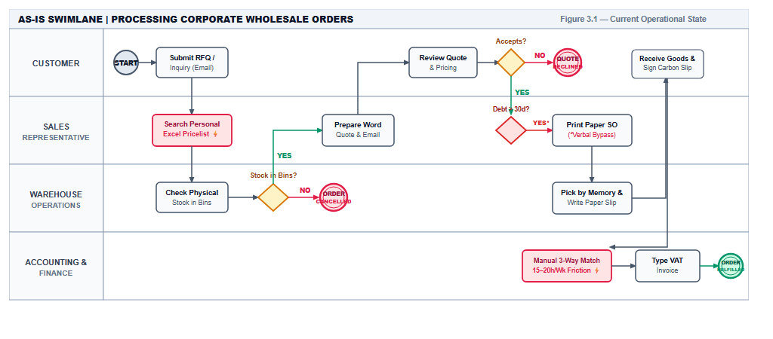
Figure 3.2: AS-IS Cross-Functional Swimlane BPMN Diagram — Current Order Fulfillment (Aligned 1:1 with Slide 12)
- Interpretation of AS-IS Model (Week 7 Rubric): Figure 3.2 illustrates the current fragmented workflow across four functional swimlanes (Customer, Sales, Warehouse, and Finance & Accounting), matching Slide 12 of the defense deck. The process contains one Start Event, three Decision Gateways, and four distinct End Events. Red and amber highlighted nodes represent acute operational friction points where information disconnects cause pricing discrepancies (P-01), post-confirmation cancellations (P-02), credit risk exposure, and excessive manual labor (P-03).
Table 3.4.1: AS-IS BPMN Swimlane Step-by-Step Specification (Aligned 1:1 with Figure 3.2 & Slide 12)
Step Label | Swimlane / Department | Actor | Action Description | Primary Artifact / Input | Transferred Output | Failure Mode / Operational Friction
Submit RFQ / Inquiry (Email) | CUSTOMER | Corporate Buyer | Submits inquiry/RFQ with list of requested SKUs via Email. | Unstructured RFQ email / message | Draft quote request | Unstructured request formats; missing SKU details or delivery date requirements.
Search Personal Excel Pricelist ⚡ | SALES REPRESENTATIVE | B2B Sales Rep | Searches personal Excel sheet stored on local laptop to look up client contract rates. | Local personal Excel pricelist | Draft line prices | [P-01] Decentralized pricelists; 5–8% billing error rate costing ~50M VND monthly in adjustments.
Check Physical Stock in Bins | SALES / WAREHOUSE | Sales Rep & Warehouse | Sales telephones Tan Binh warehouse clerk to check physical stock in bins. | Phone call inquiry | Verbal confirmation | Informal verbal check; no inventory reservation; static morning sheets miss dock changes.
Stock in Bins? (Gateway) | WAREHOUSE OPERATIONS | Warehouse Keeper | Evaluates if requested goods physically exist on pallet racks. | Visual inspection | Decision (YES / NO) | If stock unavailable: ORDER CANCELLED. Stock may look present but be already promised to another sales rep.
Prepare Word Quote & Email | SALES REPRESENTATIVE | B2B Sales Rep | Types formal quotation in Word/Excel template and emails PDF to client procurement officer. | Quotation template + verbal confirm | Formal quotation PDF | Time lag of 4–8 hours to issue quote; customer accepts or declines.
Review Quote & Pricing | CUSTOMER | Corporate Buyer | Evaluates quoted unit prices, delivery timeline, and commercial payment terms. | Received quotation document | Decision (YES / NO) | If client declines: QUOTE DECLINED.
Debt > 30d? (Gateway) | SALES REPRESENTATIVE | B2B Sales Rep | Checks customer debt aging; if debt > 30 days, requests verbal management override. | Paper AR list / verbal check | Decision (YES* / NO) | [P-03] Credit policy exists on paper but is routinely bypassed verbally to hit monthly sales quotas.
Print Paper SO (*Verbal Bypass) | SALES REPRESENTATIVE | B2B Sales Rep | Prints paper Sales Order (SO) with verbal bypass exception and commits delivery. | Confirmed order commitment | Printed Paper SO | Sales commitment made without reserving physical inventory in warehouse.
Pick by Memory & Write Paper Slip | WAREHOUSE OPERATIONS | Warehouse Picker | Walks aisles relying on memory to pick items; handwrites 3-ply carbon delivery slip. | Printed paper SO copy | Carbon Delivery Slip + Pallet | Inefficient picking paths; 3–4 stockouts/week post-SO; illegible carbon handwriting.
Receive Goods & Sign Carbon Slip | CUSTOMER | Receiving Clerk | Inspects physical goods at receiving bay and signs hard-copy carbon delivery slip. | Physical shipment + Paper slip | Signed Carbon Slip (Hard copy) | Transit delays; delivery slip physical copy takes 1–3 days to return to headquarters.
Manual 3-Way Match ⚡ | ACCOUNTING & FINANCE | AR Accountant | Collects returned paper slips and manually performs line-by-line 3-way matching. | Paper SO + Carbon Slip + Price list | Manual cross-check result | [P-03] 15–20 hours/week manual matching overhead; high discrepancy friction.
Type VAT Invoice | ACCOUNTING & FINANCE | Billing Officer | Manually types verified line items into standalone electronic invoice portal. | Matching verification result | Electronic VAT Invoice | Redundant manual data re-entry; billing delayed by 5–7 days (ORDER FULFILLED).

3.3. Process Problems, Bottlenecks & Root Cause Analysis

3.3.1. Field Evidence Register
Findings gathered during stakeholder elicitation sessions are cataloged in Table 3.5.
Table 3.5: Field Elicitation Evidence Register
Evidence ID | Stakeholder Source & Role | Verbatim Stakeholder Evidence Statement | AS-IS Factual Observation
EVD-W2-SALES-01 | Lê Thị Mai(Sales Supervisor) | "Each sales rep keeps their own Excel sheet of customer prices. When Double A updated prices last quarter, two reps kept using the old sheet for three weeks. We had to issue credit notes for 8 orders totaling 52 million VND." | Contract unit prices are retrieved from unmanaged local spreadsheets rather than a central database; 5–8% pricing error rate on invoices.
EVD-W2-WH-02 | Trần Hùng(Tan Binh Warehouse Mgr) | "Supplier delivery trucks arrive and goods sit in the receiving bay for up to two days before someone enters them into the inventory sheet. Sales calls to ask if we have stock, we say no, but the pallet was sitting right by dock 2." | Inbound receiving logs take 24–48 hours to enter into spreadsheets; sales operates without visibility into newly arrived stock.
EVD-W3-ACCT-03 | Trần Thị Mai(Chief Accountant) | "We spend almost half our working week matching paper delivery slips to sales orders and invoice drafts. When a customer has overdue debt past 30 days, sales often begs management for a verbal exception to hit monthly targets." | Accounting spends 15–20 hours weekly on manual line-by-line paper matching; paper credit hold rules are circumvented via verbal appeals.
EVD-W3-PROC-04 | Phạm Tuấn(Procurement Officer) | "We only know we are out of Double A paper when the warehouse supervisor walks over with a handwritten note saying the shelf is empty. By the time we email suppliers and get quotes back, 3 to 5 days have passed." | Replenishment is triggered reactively only after physical stockouts occur; supplier RFQ negotiation takes 2 to 3 days over email.

3.3.2. Identified Problems and Root Causes
Table 3.6 synthesizes the operational problems, their underlying root causes, and business impact.
Table 3.6: Identified Operational Problems, Root Causes, and Business Impact
Problem ID | Operational Problem / Bottleneck | Likely Root Cause in Enterprise Context | Quantified Business Impact
P-01 | Contract Pricing Discrepancies: Unit prices on invoices diverge from signed framework agreements. | Lack of a centralized contract-based pricing engine that automatically enforces contracted unit prices upon customer selection. | 5%–8% of monthly invoices contain price errors; ~50 million VND in disputed credit notes; payment delays of 15–20 days.
P-02 | Post-Confirmation Stockouts: Sales commits to delivery dates for orders that cannot be fulfilled. | Lack of a real-time Available-to-Promise (ATP) inventory visibility engine connecting Sales and multi-warehouse hubs. | 3–4 stockout emergencies per week; SLA delivery failure on 12% of orders; emergency procurement at premium prices.
P-03 | Manual 3-Way Matching Overhead: Accounting spends 15–20 hours weekly cross-checking paper documents. | Lack of automated digital 3-way matching and systematic hard credit hold enforcement connecting SOs, Delivery Notes, and Invoices. | 15–20 hours/week accounting labor wasted; delayed VAT invoice release (3–5 days); unblocked overdue debt (>30 days).

IMPORTANT ANALYTICAL DISTINCTION:
A problem describes what is not working well in the business. A root cause explains why it occurs. We do NOT label a proposed software feature (such as "add a dashboard" or "install an ERP") as the root cause. The root cause must explain the fundamental underlying process, data, or governance failure.

3.3.3. Rigorous 5-Whys Root Cause Analysis
To rigorously isolate the true process failures, the 5-Whys technique was executed for each identified problem (Table 3.7).
Table 3.7: 5-Whys Root Cause Analysis Breakdown by Core Problem
Iteration Level | Problem P-01: Contract Pricing Errors | Problem P-02: Post-Confirmation Stockouts | Problem P-03: Manual 3-Way Matching Overhead
Problem Statement | 5%–8% of customer invoices have incorrect unit prices. | Sales confirms orders that warehouse cannot fulfill. | Accounting spends 15–20 hours weekly reconciling invoices.
Why #1? | Why? Sales reps copy-paste prices from personal Excel files. | Why? Sales confirms orders based on morning stock sheets or calls. | Why? Accounting manually cross-references paper slips line by line.
Why #2? | Why personal files? Each rep manages separate files for assigned accounts. | Why outdated sheets? Warehouse inventory updates are entered in batch at end of day. | Why manual cross-checking? Signed Delivery Notes are physical paper slips.
Why #3? | Why separate files? Framework contracts are filed as scanned PDFs. | Why end-of-day batch entry? Goods receiving requires manual paper ledger logging (24–48h). | Why physical paper slips? Delivery confirmations are not captured electronically.
Why #4? | Why scanned PDFs? No central database maps contracted SKUs to client IDs. | Why manual paper receiving? Receiving docks operate disconnected from PO records. | Why no electronic matching? Sales, Warehouse, and Billing operate in isolated departmental silos.
Why #5 (Root Cause) | Lack of a centralized contract pricing engine that auto-enforces contracted rates upon client selection. | Lack of a real-time Available-to-Promise (ATP) inventory visibility engine connecting Sales and Warehouses. | Lack of automated digital 3-way matching and hard credit hold control connecting SOs, Delivery Notes, and Invoices.

3.4. Proposed Business Processes (TO-BE BPMN / Swimlane Models)

3.4.1. TO-BE Process Description & Key Changes
The proposed TO-BE business process eliminates manual paper silos by integrating Sales, Warehouse, Purchasing, and Invoicing through a central automated digital backbone. Table 3.8 outlines the specific operational transformations.
Table 3.8: Key Operational Changes from AS-IS to TO-BE
AS-IS Operational Issue | Proposed TO-BE Operational Change | Problem Addressed
Reps search personal Excel files; copy-paste rates manually. | System automatically retrieves approved framework contract prices upon selecting a corporate customer account. | P-01
Stock availability checked via phone calls; 24–48h dock receiving lag. | Real-time Available-to-Promise (ATP) stock calculation across Tan Binh and Bien Hoa hubs with automatic stock reservation upon SO confirmation. | P-02
Customer credit checked informally on paper; verbal bypasses common. | Automated hard Credit Hold gatekeeper blocks order confirmation for customer accounts with unpaid balances overdue > 30 days. | P-03
Warehouse pickers pick from memory; frequent SKU mix-ups. | Digital pick-lists generated with optimized bin location routing and barcode verification scanning at loading dock. | P-02
Drivers carry paper delivery notes; physical signatures collected. | Electronic Proof of Delivery (e-POD) sign-off captured on mobile tablet upon physical customer receipt. | P-03
Accounting manually cross-checks paper slips; 15–20h/wk overhead. | Automated 3-way matching between digital SO, e-POD delivery confirmation, and draft invoice auto-generates electronic VAT invoices. | P-03
Replenishment triggered reactively only after warehouse runs out. | Automated reorder point rules generate draft Purchase Requisitions when fast-moving paper stock falls below safety stock threshold. | P-02

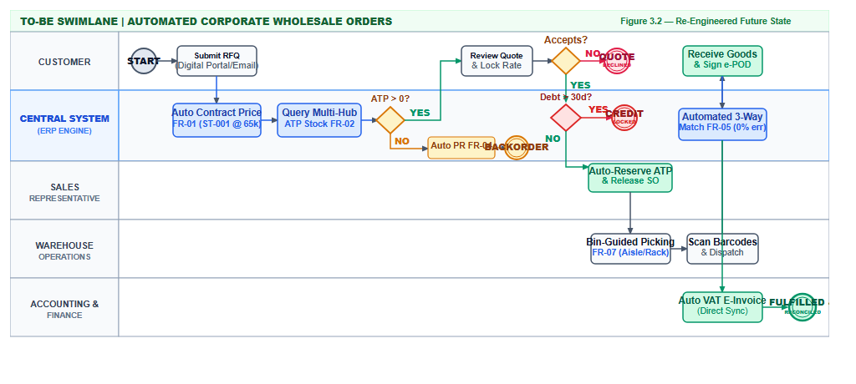
Figure 3.3: TO-BE Cross-Functional Swimlane BPMN Diagram — Automated Order Fulfillment (Aligned 1:1 with Slide 16)
- Interpretation of TO-BE Model (Week 7 Rubric): Figure 3.3 establishes the integrated future-state process model across five functional swimlanes (Customer, Central System ERP, Sales, Warehouse, and Finance & Accounting), exactly matching Slide 16 of the presentation deck. The introduction of the Central System lane automates routine data validation, real-time stock reservation, credit gating, and 3-way reconciliation. The model preserves the same business scope as the AS-IS model while providing clear handling for all four BPMN 2.0 alternative and exceptional outcomes: quote declined (End 1), backorder replenishment (End 2), credit hold (End 3), and fulfilled & reconciled (End 4).
Table 3.8.1: TO-BE BPMN Swimlane Step-by-Step Specification (Aligned 1:1 with Figure 3.3 & Slide 16)
Step Label / Node | Swimlane / Department | Automated Engine / Actor | Action Description | Associated FR ID | System Input | System Output | Elimination of AS-IS Bottleneck
Submit RFQ (Digital Portal/Email) | CUSTOMER | Corporate Buyer | Submits electronic purchase RFQ via customer digital portal or email. | — | Digital RFQ document | Unstructured data parsed into system fields | Eliminates illegible handwriting and incomplete quotation requests.
Auto Contract Price FR-01 | CENTRAL SYSTEM (ERP ENGINE) | Automated Pricing Engine | System automatically queries and applies verified framework contract price upon customer selection. | FR-01 | Customer Account ID + SKU Codes | Locked Contract Unit Price (ST-001 @ 65k) | Eliminates P-01: Completely eliminates personal Excel files; 0% price error rate on quotes.
Query Multi-Hub ATP Stock FR-02 | CENTRAL SYSTEM (ERP ENGINE) | Inventory Engine | System calculates network-wide Available-to-Promise across Tan Binh and Bien Hoa facilities. | FR-02 | SKU quantities + Real-time warehouse balance | Real-time ATP quantity per warehouse location | Eliminates P-02: Eliminates phone calls and morning spreadsheet blindspots; real-time visibility.
ATP > 0? (Gateway) | CENTRAL SYSTEM (ERP ENGINE) | Inventory Gateway | Evaluates whether current unreserved ATP quantity meets or exceeds order requirements. | FR-02 | Order quantity vs. ATP quantity | Decision: YES / NO | Prevents commitments on exhausted stock; bifurcates into quote review vs. auto PR.
Auto PR FR-04 -> BACKORDER | CENTRAL SYSTEM (ERP ENGINE) | Replenishment Engine | Generates draft Purchase Requisition when inventory is insufficient; triggers backorder. | FR-04 | Depleted inventory trigger (< 100 reams) | Draft Vendor Purchase Requisition | Eliminates P-02: Transitions procurement from reactive notes to proactive auto-replenishment (BACKORDER).
Review Quote & Lock Rate | CUSTOMER | Corporate Buyer | Reviews quotation with contract prices and locked delivery dates; decides acceptance. | FR-01 | Confirmed line items + Approved contract prices | Customer Decision (YES / NO) | Reduces quote turnaround from 4–8 hours down to minutes. If NO: QUOTE DECLINED.
Debt > 30d? (Gateway) | CENTRAL SYSTEM (ERP ENGINE) | Credit Gating Engine | Programmatic credit check: tests whether customer account has receivables overdue > 30 days. | FR-03 | Customer Accounts Receivable aging record | Decision: YES / NO | Eliminates P-03: Programmatic enforcement; stops verbal sales overrides.
CREDIT LOCKED | CENTRAL SYSTEM (ERP ENGINE) | Credit Engine | Applies programmatic Hard Credit Hold; halts SO transition and alerts Credit Controller. | FR-03 | Overdue aging trigger (> 30 days) | Credit Lock Notification + Blocked Order | Eliminates P-03: Stops bad debt accumulation at entry point (CREDIT LOCKED).
Auto-Reserve ATP & Release SO | SALES REPRESENTATIVE | Order Processing Engine | Confirms Sales Order (SO) and atomically allocates and locks inventory balance in ATP ledger. | FR-02 | Approved quote + Credit clearance | Confirmed SO + Hard Inventory Reservation | Guarantees confirmed stock cannot be double-booked by subsequent transactions.
Bin-Guided Picking FR-07 | WAREHOUSE OPERATIONS | Warehouse Engine | Automatically generates optimized digital pick-list with aisle/rack/bin routing coordinates. | FR-07 | Confirmed Sales Order line items | Digital Pick-List with bin sequence | Replaces aisle memory navigation; cuts warehouse picking travel time by over 40%.
Scan Barcodes & Dispatch | WAREHOUSE OPERATIONS | Warehouse Picker | Scans barcode labels on pallets and bins at loading dock using mobile handheld scanner. | FR-07 | Pallet/box barcodes + Digital pick-list | Validated packing scan log + Dispatched Truck | Eliminates manual shipment errors, wrong SKU dispatches, and handwritten delivery slips.
Receive Goods & Sign e-POD | CUSTOMER | Receiving Officer | Inspects delivered goods, signs digital e-POD on driver's tablet, receives immediate PDF. | — | Physical delivery + Driver tablet | Timestamped, geo-tagged e-POD signature | Eliminates lost carbon delivery slips; captures instant legal acceptance upon delivery.
Automated 3-Way Match FR-05 | CENTRAL SYSTEM (ERP ENGINE) | Reconciliation Engine | Programmatic 3-way match comparing Sales Order lines, digital e-POD, and draft invoice charges. | FR-05 | Confirmed SO + Digital e-POD + Contract Pricelist | 3-Way Match Verification (0% error tolerance) | Eliminates P-03: Replaces 15–20 hours/week of manual paper matching with zero-touch automated validation.
Auto VAT E-Invoice (Direct Sync) | ACCOUNTING & FINANCE | Invoicing Engine | Direct synchronous interface posts AR journal entry and transmits validated VAT invoice to tax authority. | FR-05, FR-08 | Validated 3-way match result | Electronic VAT Invoice + Net 30 Ledger Update | Eliminates 5–7 day billing lag (FULFILLED & RECONCILED).

3.5. Expected Process Improvements & Business Benefits
Table 3.9: Expected Process Improvements and Justified Business Benefits
Current Problem ID | TO-BE Process Change | Expected Process Improvement (Operational) | Expected Business Benefit (Strategic / Financial)
P-01: Contract Pricing Errors | System automatically locks and applies approved contract pricelists upon client selection. | Complete elimination of manual spreadsheet lookups and copy-paste steps; 100% price quotation accuracy. | Eliminates ~50 million VND monthly in billing adjustments and credit notes; prevents client payment disputes.
P-02: Receiving Lag & Stockouts | Real-time multi-hub Available-to-Promise (ATP) stock query and automated stock reservation. | Immediate stock visibility upon dock receipt; eliminates 24–48h receiving blindspot; zero double-booking of stock. | Reduces post-confirmation stockout cancellations by 95% (from 3–4/wk to near zero); protects SLA delivery commitments.
P-02: Reactive Replenishment | Automated reorder point monitoring generating draft Purchase Requisitions when stock < 100 reams. | Purchasing receives advance replenishment notifications before physical stockouts occur; lead times cut from 5 days to 24h. | Guarantees uninterrupted fulfillment for high-velocity items like Double A paper; avoids purchasing at retail premiums.
P-03: Verbal Credit Bypass | Hard automated credit hold enforced for accounts with debt overdue > 30 calendar days. | Eliminates informal verbal approvals; orders cannot transition to confirmed state without formal accounting sign-off. | 100% compliance with commercial credit policy; eliminates bad debt accumulation; accelerates cash collection cycle.
P-03: Manual 3-Way Matching | Automated 3-way matching between digital Sales Order, e-POD confirmation, and draft billing lines. | Eliminates manual line-by-line paper cross-checking; immediate automated release of electronic VAT invoices. | Reduces accounting invoice reconciliation overhead by 90% (from 15–20 hours down to 2 hours per week).

BENEFITS MUST BE JUSTIFIED:
The percentage improvements stated above are grounded directly in our verified field baselines established during Weeks 2–4 elicitation: baseline pricing error rate of 5–8% (50M VND/month), dock receiving lag of 24–48 hours, post-confirmation stockout frequency of 3–4 orders/week, and accounting reconciliation workload of 15–20 hours/week. Expected benefits reflect the direct mathematical elimination of these manual friction steps through digital integration.

SECTION 4. BUSINESS AND FUNCTIONAL REQUIREMENTS

4.1. Business Requirements (BRs)
Business Requirements describe the high-level business needs, desired outcomes, and operational capabilities that the enterprise must achieve, independent of any specific software vendor or user interface design.
Table 4.1: Formal Business Requirements (BR-01 through BR-05)
BR ID | Formal Business Requirement Statement | Related Problem / Information Need | Related Process
BR-01 | The business needs customer order commitments and quotations to be generated exclusively using verified contract pricing tiers, eliminating pricing discrepancies. | P-01: Contract Pricing ErrorsINF-SALES-01: Approved framework pricelist | BP1 / BP2Processing Orders & Pricing
BR-02 | The business needs real-time, network-wide Available-to-Promise (ATP) inventory visibility and stock reservation across all physical warehouses prior to order confirmation. | P-02: Post-Confirmation StockoutsINF-WH-01: Real-time inventory status | BP1 / BP3Orders & Stock Availability
BR-03 | The business needs commercial order confirmations to strictly enforce commercial credit policies, automatically blocking order release for accounts with debt overdue past 30 days. | P-03: Verbal Credit Policy BypassINF-ACCT-01: Overdue debt aging status | BP1 / FinanceOrder Release & Credit Control
BR-04 | The business needs inventory replenishment to be triggered automatically upon reaching defined safety thresholds, preventing operational stockouts on fast-moving SKUs. | P-02: Reactive ReplenishmentINF-PROC-01: Depletion threshold alerts | BP3 / BP5Stock Check & Replenishment
BR-05 | The business needs invoice reconciliation to be executed through automated digital 3-way matching, eliminating manual paper cross-checking and accelerating billing. | P-03: Manual 3-Way Matching OverheadINF-ACCT-02: Digital delivery confirmation | BP1 / InvoicingDelivery & Invoicing

BR WRITING CHECK:
Each Business Requirement above explains what the enterprise needs to achieve operationally to solve an identified problem. Statements like "The system shall display a red warning icon" or "The system shall send an email" are Functional Requirements (FRs), not Business Requirements.

4.2. Functional Requirements (FRs)
Functional Requirements define specific, observable, and verifiable system behaviors that the solution must exhibit to satisfy the Business Requirements. Statements adhere to the standard IEEE 830 format ("The system shall...").
Table 4.2: Prioritized Functional Requirements Catalog (FR-01 to FR-08) with Verification Ideas
FR ID | Functional Requirement Statement (IEEE 830) | Related BR | Verification / Acceptance Idea | MoSCoW Priority
FR-01 | The system shall automatically retrieve and apply approved framework contract unit prices upon selection of a verified B2B corporate customer account during quotation creation. | BR-01 | Select corporate account 'Alpha Corp' for SKU ST-001; verify unit price automatically defaults to 65,000 VND without manual entry. | MUST HAVE
FR-02 | The system shall display real-time Available-to-Promise (ATP) inventory quantities across Tan Binh Central Hub and Bien Hoa Depot during order line item entry. | BR-02 | Enter order for 50 reams of ST-001; verify system displays Tan Binh ATP (120 reams) and Bien Hoa ATP (30 reams) accurately. | MUST HAVE
FR-03 | The system shall automatically apply a hard Credit Hold on order confirmation for any customer account with an outstanding invoice overdue by more than 30 calendar days. | BR-03 | Attempt to confirm SO for client with 35-day overdue invoice; verify system locks confirmation and displays 'Credit Hold - Overdue > 30 Days'. | MUST HAVE
FR-04 | The system shall automatically generate a draft Purchase Requisition when the unreserved on-hand quantity of a designated fast-moving SKU falls below its safety reorder threshold. | BR-04 | Reduce ST-001 ATP stock to 90 reams (threshold = 100); verify system auto-generates draft Purchase Requisition for 200 reams. | MUST HAVE
FR-05 | The system shall execute automated 3-way line item matching between the confirmed Sales Order, verified electronic Delivery Note (e-POD), and draft Billing Invoice. | BR-05 | Complete e-POD delivery sign-off; verify system automatically reconciles delivered quantities and releases electronic VAT invoice without manual review. | MUST HAVE
FR-06 | The system shall issue automated notification alerts to assigned account representatives 30 calendar days prior to customer framework contract agreement expiration dates. | BR-01 | Simulate contract expiration date in 29 days; verify automated notification appears on sales rep dashboard and via email. | SHOULD HAVE
FR-07 | The system shall generate a multi-vendor RFQ price and delivery lead-time comparison matrix upon receipt of vendor quotation submissions. | BR-04 | Submit 3 vendor quotes for ST-001; verify system renders side-by-side comparison table highlighting lowest cost and shortest lead time. | SHOULD HAVE
FR-08 | The system shall render an executive Accounts Receivable aging dashboard displaying total outstanding debt categorized into Current, 1–30 Days, 31–60 Days, and >60 Days buckets. | BR-03 | Open AR dashboard; verify aging debt amounts correctly aggregate and filter by customer tier and days overdue. | COULD HAVE

FR WRITING CHECK:
Each Functional Requirement above specifies a clear, testable system behavior with measurable verification criteria. Vague terms such as "the system should be user-friendly" or "the system should work fast" have been rigorously excluded.

4.3. Business Rules & Operational Constraints

4.3.1. Formal Business Rules Matrix
Business Rules define the policies and operational constraints that govern enterprise operations. Table 4.3 distinguishes business rules from software functions.
Table 4.3: Core Enterprise Business Rules Matrix
Rule ID | Formal Business Rule / Policy Statement | Operational Rationale | Enforcement Mechanism | Related BR / FR
BR-R01 | Contract Price Locking: Unit prices for contracted SKUs (ST-001 to ST-010) must strictly match the active framework contract. Standard sales representatives are prohibited from editing contracted rates. | Prevents unauthorized discounting and rate errors; protects 20–25% corporate margin. | System permission locks unit price field for standard sales roles. | BR-01FR-01
BR-R02 | Discretionary Discount Ceiling: Sales representatives may apply an ad-hoc commercial discount of up to 5.0%. Any discount exceeding 5.0% requires formal electronic approval from the Sales Manager. | Prevents margin erosion while allowing field sales reasonable closing flexibility. | Automated approval workflow; locks SO confirmation if discount > 5.0%. | BR-01FR-01
BR-R03 | Hard Credit Lock Policy: Any customer account with an outstanding invoice overdue by more than 30 calendar days shall be placed on automated Credit Hold. No new orders may be released without Chief Accountant clearance. | Mitigates severe cash flow risk and stops bad debt accumulation from chronic late-payers. | Automated system gatekeeper; disables 'Confirm Order' button. | BR-03FR-03
BR-R04 | Available-to-Promise (ATP) Allocation: Order confirmation is permitted only if total order quantity $le$ network ATP stock. Tan Binh Hub is allocated first; Bien Hoa Depot serves as regional secondary. | Eliminates double-booking of stock; guarantees 100% fulfillable order commitments. | Multi-facility inventory query and automated stock reservation lock. | BR-02FR-02
BR-R05 | Automated Replenishment Trigger: When unreserved on-hand stock of fast-movers (ST-001 Double A, ST-002 IK Plus) drops below 100 reams, an automated Purchase Requisition must be generated. | Prevents stockout crises on highest-velocity revenue drivers (paper represents 45% volume). | Automated inventory batch trigger event; alerts Procurement Officer. | BR-04FR-04
BR-R06 | Mandatory 3-Way Reconciliation: An Accounts Receivable VAT electronic invoice can only be released after successful 3-way matching between (1) Confirmed SO, (2) Signed e-POD, and (3) Invoice Line Items. | Eliminates invoicing errors, customer billing disputes, and accounting fraud. | Automated 3-way tolerance matching algorithm (zero discrepancy). | BR-05FR-05

4.3.2. Operational Constraints
The implementation of the proposed business requirements operates under specific real-world operational constraints:
- Multi-Facility Logistics Constraint: The physical distance between Tan Binh Central Hub and Bien Hoa Depot requires a minimum inter-warehouse transfer window of 4 hours under standard traffic conditions.
- Master Data Catalog Constraint: The Phase 1 analysis and validation baseline is strictly scoped to the 10 primary commercial SKUs (ST-001 through ST-010). Additional product lines are deferred to subsequent phases.
- Credit Term Constraint: Commercial credit terms are restricted to verified Tier-1 and Tier-2 accounts under signed framework agreements; Tier-3 retail sub-dealers operate under cash-on-delivery (COD) or immediate bank transfer terms.
- Regulatory Compliance Constraint: Electronic VAT invoice generation must strictly adhere to Vietnamese tax regulations (Decree 123/2020/ND-CP and Circular 78/2021/TT-BTC) regarding electronic invoice formatting and tax authority digital signing.

4.4. Requirements Traceability Matrix (RTM)

4.4.1. Traceability Methodology & Chain
The Requirements Traceability Matrix demonstrates end-to-end bidirectional traceability from verified field elicitation evidence through business problems, information needs, business requirements, and functional specifications to TO-BE process changes:
$$
ext{Evidence (EVD)} longrightarrow ext{AS-IS Observation} longrightarrow ext{Business Problem (P)} longrightarrow ext{Information Need (INF)} longrightarrow ext{Business Requirement (BR)} longrightarrow ext{Functional Requirement (FR)} longrightarrow ext{TO-BE Change}
$$

4.4.2. End-to-End Requirements Traceability Matrix
Table 4.4 documents the complete traceability chain for OfficePro Distribution Co., Ltd.
Table 4.4: End-to-End Requirements Traceability Matrix (RTM)
Evidence ID / Source | AS-IS Factual Observation | Problem ID / Information Need | BR ID | FR ID & Priority | Proposed TO-BE Operational Change | Related Process
EVD-W2-SALES-01(Sales Interview) | Reps copy rates from personal Excel files into quotations; 5–8% rate error on invoices. | P-01 (Contract Pricing Errors)INF-SALES-01 (Approved contract pricelist) | BR-01 | FR-01(MUST HAVE) | System automatically applies approved contract pricelist upon selecting corporate account; disables manual edits. | BP1 / BP2Processing Orders & Pricing
EVD-W2-WH-02(Warehouse Observation) | Dock receiving entries lag by 24–48h; reps make verbal phone inquiries; stockouts occur post-SO. | P-02 (Post-Confirmation Stockouts)INF-WH-01 (Real-time inventory status) | BR-02 | FR-02(MUST HAVE) | Real-time multi-hub Available-to-Promise (ATP) stock displayed across Tan Binh & Bien Hoa; stock reserved on SO confirm. | BP1 / BP3Orders & Stock Availability
EVD-W3-ACCT-03(Chief Accountant Interview) | Reps bypass credit limits via verbal appeals; debtors overdue > 30 days continue placing orders. | P-03 (Credit Policy Bypass)INF-ACCT-01 (Overdue debt aging status) | BR-03 | FR-03(MUST HAVE) | Automated hard Credit Hold blocks order confirmation for any account with unpaid invoices overdue past 30 days. | BP1 / FinanceOrder Release & Credit Control
EVD-W3-PROC-04(Procurement Officer Interview) | Replenishment is triggered manually via handwritten notes only after warehouse bins run empty. | P-02 (Reactive Replenishment)INF-PROC-01 (Depletion threshold alerts) | BR-04 | FR-04(MUST HAVE) | Automated reorder point monitoring generates draft Purchase Requisition when paper stock drops below 100 reams. | BP3 / BP5Stock Check & Replenishment
EVD-W3-ACCT-03(Chief Accountant Interview) | Accounting spends 15–20h/week manually cross-checking physical paper delivery notes against SOs. | P-03 (Manual Matching Overhead)INF-ACCT-02 (Digital delivery receipt) | BR-05 | FR-05(MUST HAVE) | Automated 3-way matching between digital SO, e-POD confirmation, and draft billing lines auto-releases electronic VAT invoices. | BP1 / InvoicingDelivery & Invoicing
EVD-W4-SIM-02(Simulation Findings) | Expired framework contracts cause customer billing disputes and delayed contract renewals. | P-01 (Expired Contract Disputes)INF-SALES-02 (Contract expiration dates) | BR-01 | FR-06(SHOULD HAVE) | Automated reminder alerts notify account reps 30 days prior to framework contract agreement expiration dates. | BP2Verifying Contract Prices
EVD-W3-PROC-04(Procurement Officer Interview) | Purchasing officers spend 2–3 days compiling supplier quotes from unstructured email threads. | P-02 (Vendor Selection Delays)INF-PROC-02 (Multi-vendor quote comparison) | BR-04 | FR-07(SHOULD HAVE) | Multi-vendor RFQ comparison matrix generated automatically to compare supplier pricing and delivery lead times. | BP5Reviewing Replenishment Needs
EVD-W3-MGMT-05(Management Interview) | Executive management lacks visibility into corporate debt aging and cash collection forecasts. | P-03 (Cash Flow Blindspots)INF-MGMT-01 (AR debt aging metrics) | BR-03 | FR-08(COULD HAVE) | Executive Accounts Receivable aging dashboard rendering debt buckets (Current, 1–30, 31–60, >60 days overdue). | BP1 / FinanceExecutive Financial Reporting

TRACEABILITY IS NOT JUST ID MATCHING:
A valid traceability link must reflect genuine operational semantics. In Table 4.4, every single requirement traces backwards to a verified field observation and forward to a concrete process improvement. There are zero "orphan" requirements (features without business justification) and zero unaddressed operational problems.

SECTION 5. USE CASE ANALYSIS

5.1. Enterprise Use Case Diagram
The Enterprise Use Case Diagram delineates the boundary of the proposed enterprise solution for OfficePro Distribution Co., Ltd., mapping system actors to operational goals across the four core integrated functional domains: Sales, Inventory, Procurement, and Invoicing/Accounting.
Figure 5.1: Enterprise Use Case Diagram — OfficePro Distribution ERP Architecture

5.2. Use Case Identification & Catalog
Table 5.1 categorizes all identified enterprise use cases across the four core modules, establishing their direct linkages to the prioritized Functional Requirements (FR-01 to FR-08) and operational business rules.
Table 5.1: Enterprise Use Case Catalog & Operational Boundary
Use Case ID | Use Case Name | Primary Business Domain | Primary Actor | Associated FR ID | Associated Business Rule | MoSCoW Priority
UC-SALES-01 | Apply Contract Pricing & Generate Quotation | Sales Management | B2B Sales Representative | FR-01 | BR-R01, BR-R02 | MUST HAVE
UC-SALES-02 | Query Real-Time Multi-Hub ATP Stock | Sales & Inventory | B2B Sales Representative | FR-02 | BR-R04 | MUST HAVE
UC-SALES-03 | Request Discretionary Discount Approval (> 5%) | Sales Governance | B2B Sales Representative | FR-01 | BR-R02 | SHOULD HAVE
UC-SALES-04 | Confirm B2B Sales Order & Reserve ATP Stock | Order Processing | B2B Sales Representative | FR-01, FR-02 | BR-R01, BR-R04 | MUST HAVE
UC-INV-01 | Inbound Receiving & Barcode Logging | Warehouse Operations | Warehouse Keeper | FR-02 | BR-R04 | MUST HAVE
UC-INV-02 | Bin-Guided Picking & Barcode Verification | Warehouse Operations | Warehouse Picker | FR-07 | BR-R04 | MUST HAVE
UC-INV-03 | Electronic Proof of Delivery (e-POD) Sign-off | Delivery & Logistics | Customer Receiving Officer | FR-05 | BR-R06 | MUST HAVE
UC-INV-04 | Safety Stock Monitoring & ATP Balance Audit | Inventory Control | Inventory Controller | FR-04 | BR-R05 | MUST HAVE
UC-PURCH-01 | Automated Reorder Trigger & Draft PR Generation | Procurement | Procurement Officer | FR-04 | BR-R05 | MUST HAVE
UC-PURCH-02 | Multi-Vendor RFQ Comparison & PO Award | Procurement | Procurement Officer | FR-07 | BR-R05 | SHOULD HAVE
UC-ACC-01 | Automated Digital 3-Way Document Matching | Financial Invoicing | Billing Officer | FR-05 | BR-R06 | MUST HAVE
UC-ACC-02 | Enforce Hard Credit Lock (Debt > 30 Days) | Commercial Credit | System Gatekeeper | FR-03 | BR-R03 | MUST HAVE
UC-ACC-03 | Issue & Register Electronic VAT Invoice | Invoicing & Tax | Billing Officer | FR-05 | BR-R06 | MUST HAVE
UC-ACC-04 | Accounts Receivable Aging & Net 30 Monitoring | Financial Management | Chief Accountant | FR-08 | BR-R03 | COULD HAVE

5.3. Detailed Use Case Specifications
To adhere to the highest academic rigor (Alistair Cockburn & IEEE 830 standards), comprehensive use case specifications are detailed below for the core functional requirements governing the re-engineered TO-BE operational model.

5.3.1. UC-SALES-01: Apply Contract Pricing & Generate Quotation
Table 5.2: Detailed Use Case Specification — UC-SALES-01
Attribute | Specification Details
Use Case ID | UC-SALES-01
Use Case Name | Apply Contract Pricing & Generate Quotation
Module / Domain | Sales Management (Odoo Sales Module)
Associated FR / BR | FR-01 (Contract Pricing Engine) | BR-R01 (Contract Price Lock) | BR-R02 (5% Discount Ceiling)
Primary Actor | B2B Sales Representative
Secondary Actors | Corporate Customer (Recipient), Sales Manager (Approver for overrides)
Scope & Level | Enterprise System Level | User-Goal Level
Trigger | B2B Customer submits an RFQ or product quotation inquiry via email, phone, or digital customer portal.
Pre-conditions | 1. The Sales Rep is authenticated into Odoo with active 'Salesperson' role permissions.<br/>2. Customer account exists in Odoo with active 'B2B Corporate Contract Pricelist' assigned.<br/>3. Master data items (e.g., ST-001) have verified contract rates established in the system pricelist.
Post-conditions (Success) | 1. Quotation created with locked framework contract unit prices (e.g., ST-001 @ 65,000 VND).<br/>2. Discretionary discount validated (<= 5.0%).<br/>3. Formal quotation PDF generated and transmitted electronically to customer contact with audit timestamp.
Post-conditions (Failure) | Quotation remains in draft state; error banner displayed; no quotation transmitted to customer.
Main Success Scenario (Happy Path) | Step 1 (Actor): Sales Rep navigates to Sales -> Orders -> Quotations and clicks New.<br/>Step 2 (Actor): Rep selects customer account (e.g., 'Corporate Account A - Saigon Tech Corp').<br/>Step 3 (System): System automatically identifies customer profile, defaults payment terms to '30 Days (Net 30)', and locks active pricelist to 'B2B Corporate Contract Pricelist (Net 30)'.<br/>Step 4 (Actor): Rep adds order line item ST-001 (A4 Double A 70gsm) with quantity 100 reams.<br/>Step 5 (System): Programmatic pricing engine retrieves fixed contract rate of 65,000 VND/ream (discounted from standard 75,000 VND), applies 10% VAT, computes line subtotal of 6,500,000 VND, and displays margin analysis.<br/>Step 6 (System): System locks unit price field to prevent manual editing per rule BR-R01.<br/>Step 7 (Actor): Rep clicks Send by Email to transmit standardized quote PDF to client.<br/>Step 8 (System): System generates formal PDF with encrypted quotation reference, logs audit record in chatter, and transitions status to Quotation Sent.
Extensions / Alternative Flows | 4a. Item not in customer contract pricelist:<br/>&nbsp;&nbsp;4a1. System applies standard retail list price (e.g., 75,000 VND for Double A).<br/>&nbsp;&nbsp;4a2. System alerts rep: 'Standard list price applied — SKU not under active framework contract'.<br/>5a. Sales Rep applies commercial discount <= 5.0%:<br/>&nbsp;&nbsp;5a1. System verifies discount rate <= 5.0% threshold.<br/>&nbsp;&nbsp;5a2. System updates net unit price and recalculates taxes automatically per BR-R02.<br/>5b. Sales Rep requests discount > 5.0%:<br/>&nbsp;&nbsp;5b1. System blocks immediate email dispatch and flags quotation as Pending Managerial Approval.<br/>&nbsp;&nbsp;5b2. System routes automated electronic approval notification to Sales Manager.<br/>&nbsp;&nbsp;5b3. Sales Manager reviews gross margin impact on executive dashboard and clicks Approve or Reject.<br/>&nbsp;&nbsp;5b4. If approved, quotation unlocks for customer transmission; if rejected, unit price reverts to baseline contract rate.
Exception Flows | 2a. Inactive or Suspended Customer Account:<br/>&nbsp;&nbsp;2a1. System halts quotation entry and displays error: 'Account suspended — Contact Credit Control'.<br/>5c. Contract Agreement Expired:<br/>&nbsp;&nbsp;5c1. System detects framework contract expiration date < Current Date.<br/>&nbsp;&nbsp;5c2. System blocks contract rate application and prompts rep to initiate contract renewal workflow.

5.3.2. UC-SALES-02: Query Real-Time Multi-Hub ATP Stock
Table 5.3: Detailed Use Case Specification — UC-SALES-02
Attribute | Specification Details
Use Case ID | UC-SALES-02
Use Case Name | Query Real-Time Multi-Hub ATP Stock
Module / Domain | Sales & Inventory Operations (Odoo Inventory / Sales)
Associated FR / BR | FR-02 (Multi-Facility ATP Engine) | BR-R04 (ATP Inventory Allocation Rule)
Primary Actor | B2B Sales Representative
Secondary Actors | Warehouse Keeper (Stock Custodian), Inventory Controller
Scope & Level | Enterprise System Level | Subfunction Level
Trigger | Sales Rep enters SKU line items during quotation or sales order entry.
Pre-conditions | 1. Real-time multi-location inventory tracking enabled across Tan Binh Central Hub and Bien Hoa Depot.<br/>2. Product barcode, on-hand count, and committed reservations accurately registered in Odoo inventory ledger.
Post-conditions (Success) | 1. System computes and displays verified ATP ($ATP = OnHand - Committed - SafetyStock$) per physical warehouse.<br/>2. Sales rep receives immediate visual green/red indicator of stock fulfillability before confirming customer commitment.
Post-conditions (Failure) | Stock warning displayed; confirmation button disabled if requested quantity exceeds total unreserved network ATP.
Main Success Scenario (Happy Path) | Step 1 (Actor): Sales Rep enters line item SKU ST-001 and inputs requested quantity (e.g., 50 reams).<br/>Step 2 (System): ATP Engine executes multi-location inventory query: retrieves Tan Binh on-hand (120 reams, 20 reserved $ ightarrow$ ATP = 100) and Bien Hoa on-hand (30 reams, 0 reserved $ ightarrow$ ATP = 30).<br/>Step 3 (System): System verifies requested quantity (50 reams) <= Tan Binh ATP (100 reams).<br/>Step 4 (System): System renders green forecast stock indicator (Available on order date) and allocates Tan Binh Hub as primary fulfillment warehouse.<br/>Step 5 (Actor): Rep proceeds to confirm sales order with guaranteed delivery commitment.
Extensions / Alternative Flows | 3a. Tan Binh stock insufficient, but network ATP sufficient:<br/>&nbsp;&nbsp;3a1. Requested quantity is 110 reams (Tan Binh ATP = 100, Bien Hoa ATP = 30).<br/>&nbsp;&nbsp;3a2. System proposes split fulfillment or automated inter-warehouse stock transfer from Bien Hoa to Tan Binh.<br/>&nbsp;&nbsp;3a3. System calculates required transit buffer (4 hours per logistics constraint) and updates customer delivery lead time to +24 hours.<br/>3b. Total network ATP is 0 (Out of Stock):<br/>&nbsp;&nbsp;3b1. System renders high-visibility red stock warning chip (Forecasted Stock: 0 Available).<br/>&nbsp;&nbsp;3b2. System displays expected inbound receipt date from approved supplier Purchase Orders.<br/>&nbsp;&nbsp;3b3. If customer accepts backorder, system flags line item for automated replenishment link (UC-PURCH-01).
Exception Flows | 2a. Warehouse location unreachable / synchronization error:<br/>&nbsp;&nbsp;2a1. System falls back to last verified inventory closing snapshot and flags line item as 'ATP verification unconfirmed — Supervisor review required'.

5.3.3. UC-ACC-02: Enforce Hard Credit Lock (Debt > 30 Days)
Table 5.4: Detailed Use Case Specification — UC-ACC-02
Attribute | Specification Details
Use Case ID | UC-ACC-02
Use Case Name | Enforce Hard Credit Lock (Debt > 30 Days)
Module / Domain | Financial Management & Commercial Credit Control (Odoo Invoicing)
Associated FR / BR | FR-03 (Automated Hard Credit Lock) | BR-R03 (Hard Credit Hold Policy)
Primary Actor | System Gatekeeper (Automated Background Policy Engine)
Secondary Actors | B2B Sales Representative (Blocked Actor), Chief Accountant (Authorized Approver)
Scope & Level | Enterprise System Level | Business Rule Enforcement Level
Trigger | Sales Representative attempts to click Confirm on a quotation to convert it into a formal Sales Order.
Pre-conditions | 1. Customer account has Net 30 commercial payment terms established.<br/>2. Open invoice records and payment journal entries exist in Odoo accounting database.
Post-conditions (Success) | 1. If overdue balance > 30 days exists, SO confirmation is strictly blocked; order remains locked in draft/quotation state.<br/>2. Automated credit hold notification logged in chatter and dispatched to Chief Accountant.
Post-conditions (Failure) | If credit status is healthy (no overdue debt > 30 days and order within credit limit), order confirms successfully and releases to warehouse picking.
Main Success Scenario (Happy Path - Clean Credit) | Step 1 (Actor): Sales Rep clicks Confirm on Quotation S00001 for customer 'Saigon Tech Corp'.<br/>Step 2 (System): Credit Gating Engine queries Accounts Receivable aging subledger for customer ID.<br/>Step 3 (System): System calculates total outstanding balance, identifies oldest unpaid invoice date, and checks against current date: Oldest invoice age = 12 days (<= 30 days threshold).<br/>Step 4 (System): System verifies total exposure (Current AR + New Order Value) <= Approved Credit Limit (200,000,000 VND).<br/>Step 5 (System): System validates credit clearance, converts Quotation to Sales Order (Status: Sale), reserves inventory ATP, and auto-generates delivery order WH/OUT/00001.
Extensions / Alternative Flows (Credit Violation - Hard Lock) | 3a. Customer has invoice overdue > 30 calendar days:<br/>&nbsp;&nbsp;3a1. System identifies invoice INV/2026/00088 overdue by 35 days (Unpaid balance: 42,000,000 VND).<br/>&nbsp;&nbsp;3a2. System immediately aborts SO confirmation and executes programmatic Hard Credit Lock.<br/>&nbsp;&nbsp;3a3. System displays modal dialog: 'Credit Hold: Customer has outstanding invoices overdue past 30 days. Order confirmation blocked per corporate credit policy BR-R03.'<br/>&nbsp;&nbsp;3a4. System disables Confirm button for sales role and posts audit record to chatter.<br/>&nbsp;&nbsp;3a5. Automated alert sent to Chief Accountant containing overdue invoice aging breakdown.<br/>3b. Chief Accountant clears exception upon partial payment:<br/>&nbsp;&nbsp;3b1. Customer wire transfer arrives; Chief Accountant registers payment in Odoo bank reconciliation.<br/>&nbsp;&nbsp;3b2. Overdue balance clears below 30-day threshold.<br/>&nbsp;&nbsp;3b3. System automatically releases credit hold; Sales Rep can now confirm order.
Exception Flows | 4a. Credit Limit Exceeded without Overdue Debt:<br/>&nbsp;&nbsp;4a1. Customer has clean aging (< 30 days) but new order causes exposure to exceed 200M VND ceiling.<br/>&nbsp;&nbsp;4a2. System flags order for 'Credit Limit Overextension Approval' requiring Chief Accountant electronic co-signature.

5.3.4. UC-PURCH-01: Automated Reorder Trigger & Draft PR Generation
Table 5.5: Detailed Use Case Specification — UC-PURCH-01
Attribute | Specification Details
Use Case ID | UC-PURCH-01
Use Case Name | Automated Reorder Trigger & Draft PR Generation
Module / Domain | Procurement & Inventory Replenishment (Odoo Purchase / Inventory)
Associated FR / BR | FR-04 (Automated Purchase Requisition Trigger) | BR-R05 (Replenishment Safety Threshold)
Primary Actor | Automated Inventory Scheduler (System Daemon)
Secondary Actors | Procurement Officer (Reviewer/Buyer), Primary Vendor (Supplier)
Scope & Level | Enterprise System Level | System-Scheduled Level
Trigger | Unreserved on-hand inventory quantity for a designated SKU falls below configured minimum reorder point (e.g., < 100 reams for ST-001).
Pre-conditions | 1. Reordering rules configured in Odoo Inventory with Min/Max thresholds (Min = 100, Max = 300 reams).<br/>2. Preferred vendor relationship, purchase unit price, and vendor lead times established on product master.
Post-conditions (Success) | 1. System auto-generates draft Purchase Requisition / Request for Quotation (RFQ) in Purchase module.<br/>2. Quantity automatically calculated to restore stock to configured Maximum level ($ReorderQty = Max - ProjectedQty$).<br/>3. Procurement Officer notified via procurement dashboard.
Post-conditions (Failure) | Stock depletion unflagged; potential stockout crisis occurs.
Main Success Scenario (Happy Path) | Step 1 (System): Sales confirmation consumes 50 reams of ST-001; unreserved inventory balance drops to 70 reams.<br/>Step 2 (System): Automated Reorder Daemon executes stock threshold check: verifies Current Balance (70) < Minimum Safety Threshold (100).<br/>Step 3 (System): System triggers automated replenishment logic: calculates replenishment deficit to restore stock to Max (300): $OrderQty = 300 - 70 = 230$ reams.<br/>Step 4 (System): System queries product vendor profile: identifies primary vendor 'Double A Paper Mill Ltd.' with pre-agreed contract purchase rate of 52,000 VND/ream and lead time of 3 days.<br/>Step 5 (System): System automatically creates draft Purchase Order P00004 in Purchase -> Requests for Quotation with line item 230 reams @ 52,000 VND = 11,960,000 VND.<br/>Step 6 (System): System routes notification alert to Procurement Officer dashboard.<br/>Step 7 (Actor): Procurement Officer reviews auto-generated PR, verifies budget allocation, and clicks Confirm Order to issue PO to manufacturer.
Extensions / Alternative Flows | 4a. Multi-Vendor RFQ Comparison Enabled (FR-07):<br/>&nbsp;&nbsp;4a1. System creates draft RFQs across 3 registered paper distributors (Double A, IK Plus, PaperOne).<br/>&nbsp;&nbsp;4a2. System renders side-by-side price, lead time, and payment terms comparison matrix.<br/>&nbsp;&nbsp;4a3. Procurement Officer selects optimal vendor based on delivery urgency and cash flow requirements.
Exception Flows | 4b. Vendor Contract Expired / Missing Supplier Record:<br/>&nbsp;&nbsp;4b1. System generates unassigned PR and issues high-priority warning: 'No active vendor pricebook for SKU ST-001 — Manual buyer assignment required'.

5.3.5. UC-ACC-01: Automated Digital 3-Way Document Matching
Table 5.6: Detailed Use Case Specification — UC-ACC-01
Attribute | Specification Details
Use Case ID | UC-ACC-01
Use Case Name | Automated Digital 3-Way Document Matching
Module / Domain | Financial Billing & Accounts Receivable (Odoo Invoicing)
Associated FR / BR | FR-05 (Automated 3-Way Reconciliation) | BR-R06 (Mandatory 3-Way Match Rule)
Primary Actor | Billing Officer / AR Accountant
Secondary Actors | Warehouse Dispatcher (POD Originator), Tax Authority (E-Invoice Recipient)
Scope & Level | Enterprise System Level | User-Goal Level
Trigger | Delivery truck completes delivery and customer signs electronic Proof of Delivery (e-POD) on driver tablet.
Pre-conditions | 1. Confirmed Sales Order (S00001) exists with locked unit rates.<br/>2. Warehouse Delivery Order (WH/OUT/00001) validated with physical shipped quantities.<br/>3. Customer digital e-POD signature captured and synced to ERP.
Post-conditions (Success) | 1. Programmatic 3-way match verifies 0% discrepancy across SO lines, delivered quantities, and draft invoice charges.<br/>2. Commercial VAT Electronic Invoice (INV/2026/00001) transitioned to Posted state.<br/>3. General ledger journal entries posted; Net 30 payment countdown initiated.
Post-conditions (Failure) | Invoice locked in Draft; mismatch exception logged; notification sent to AR Supervisor.
Main Success Scenario (Happy Path) | Step 1 (System): e-POD synchronization event notifies Invoicing module that order WH/OUT/00001 is fully delivered.<br/>Step 2 (Actor): Billing Officer navigates to Invoicing -> Customers -> Invoices and clicks Create Invoice (from Delivered Orders).<br/>Step 3 (System): Automated 3-Way Matching Engine executes programmatic line-by-line cross-check: <br/>&nbsp;&nbsp;• Match Dimension 1 (Quantity): Confirmed SO quantity (100 reams) $equiv$ Delivered quantity (100 reams).<br/>&nbsp;&nbsp;• Match Dimension 2 (Unit Price): Invoiced unit rate (65,000 VND) $equiv$ Approved contract framework rate (65,000 VND).<br/>&nbsp;&nbsp;• Match Dimension 3 (Tax & Terms): VAT rate (10%) and payment terms ('30 Days') $equiv$ Master framework contract terms.<br/>Step 4 (System): System validates zero-discrepancy (Tolerance = 0%), generates draft VAT Invoice INV/2026/00001, and displays green '3-Way Reconciled' badge.<br/>Step 5 (Actor): Billing Officer clicks Confirm.<br/>Step 6 (System): System posts invoice to General Ledger: Debits Accounts Receivable (131) 7,150,000 VND, Credits Sales Revenue (511) 6,500,000 VND, Credits Output VAT (3331) 650,000 VND.<br/>Step 7 (System): System computes exact due date (Invoice Date + 30 days) and transmits electronic VAT invoice XML/PDF to customer email and tax portal.
Extensions / Alternative Flows (Discrepancy Exception) | 3a. Partial Delivery Discrepancy (Delivered < Ordered):<br/>&nbsp;&nbsp;3a1. Customer ordered 100 reams, but warehouse only delivered 80 reams due to truck capacity.<br/>&nbsp;&nbsp;3a2. 3-Way Match algorithm detects quantity divergence (100 ordered vs. 80 delivered).<br/>&nbsp;&nbsp;3a3. System enforces strict billing on delivered quantities only per BR-R06: auto-adjusts invoice quantity to 80 reams.<br/>&nbsp;&nbsp;3a4. Backorder delivery slip (WH/OUT/00002) generated for remaining 20 reams.
Exception Flows | 3b. Price Mismatch Detected (Unit Price != Contract Price):<br/>&nbsp;&nbsp;3b1. System detects billing rate differs from active contract pricelist.<br/>&nbsp;&nbsp;3b2. System halts invoice confirmation, flags document as 'Price Discrepancy Hold', and alerts Chief Accountant.

5.3.6. UC-INV-02: Bin-Guided Picking & Barcode Verification
Table 5.7: Detailed Use Case Specification — UC-INV-02
Attribute | Specification Details
Use Case ID | UC-INV-02
Use Case Name | Bin-Guided Picking & Barcode Verification
Module / Domain | Warehouse Operations & Logistics (Odoo Inventory)
Associated FR / BR | FR-07 / Operational Logistics | BR-R04 (Multi-Facility Fulfillment Rule)
Primary Actor | Warehouse Picker
Secondary Actors | Dispatch Controller, Delivery Driver
Scope & Level | Enterprise System Level | Task Level
Trigger | Sales Order is confirmed and releases Delivery Order WH/OUT/00001 to Tan Binh Central Hub.
Pre-conditions | 1. Warehouse pallet racks mapped with standardized bin coordinates (Aisle / Section / Shelf / Level).<br/>2. Mobile barcode handheld terminals active and connected to ERP Wi-Fi network.
Post-conditions (Success) | 1. System generates optimized pick-list routing path through warehouse aisles.<br/>2. Picker scans physical pallet barcodes; 100% SKU and quantity accuracy validated before staging.
Post-conditions (Failure) | Barcode mismatch error triggered; picker prevented from staging incorrect items.
Main Success Scenario (Happy Path) | Step 1 (System): Order confirmation generates Delivery Order WH/OUT/00001 and assigns it to Tan Binh picking queue.<br/>Step 2 (Actor): Warehouse Picker logs into mobile terminal and opens picking task.<br/>Step 3 (System): System displays picking list ordered by optimal travel sequence: displays bin coordinate TB-A02-S03-L1 for SKU ST-001 (Double A 70gsm).<br/>Step 4 (Actor): Picker navigates directly to aisle A02, shelf S03 without relying on personal memory.<br/>Step 5 (Actor): Picker scans pallet barcode 8851976000014 using handheld scanner.<br/>Step 6 (System): Terminal validates scanned barcode against expected SKU code, chimes green confirmation tone, and registers picked quantity (100 reams).<br/>Step 7 (Actor): Picker moves pallet to Loading Dock Bay 2 and clicks Validate Dispatch.<br/>Step 8 (System): System deducts 100 reams from on-hand inventory, generates digital Delivery Note, and syncs manifest to driver tablet.
Extensions / Alternative Flows | 5a. Wrong SKU Barcode Scanned (e.g., IK Plus instead of Double A):<br/>&nbsp;&nbsp;5a1. Picker accidentally scans barcode of nearby pallet (ST-002 IK Plus 70gsm).<br/>&nbsp;&nbsp;5a2. Mobile terminal flashes red warning screen and emits error alarm: 'SKU Mismatch — Expected: ST-001 Double A, Scanned: ST-002 IK Plus'. <br/>&nbsp;&nbsp;5a3. Terminal locks task progression until correct SKU barcode is scanned, completely eliminating wrong SKU dispatch errors.
Exception Flows | 6a. Pallet Barcode Damaged / Unreadable:<br/>&nbsp;&nbsp;6a1. Picker requests Warehouse Supervisor override via badge scan to input serial verification manually.

5.4. Use Case Traceability & Verification Matrix
Table 5.8 proves complete bidirectional alignment, verifying that every functional requirement, business rule, and operational problem established in Phase 1 is fully realized by a specific use case specification.
Table 5.8: Use Case to Requirements & Business Rules Traceability Matrix
Business Problem ID | Root Cause Summary | Business Requirement (BR) | Functional Requirement (FR) | Business Rule (BR-R) | Realizing Use Case ID | Verification Method
P-01 | Decentralized local Excel files | BR-01 | FR-01 (MUST) | BR-R01, BR-R02 | UC-SALES-01 | Automated pricelist retrieval test
P-02 | Dock receiving lag & phone inquiries | BR-02 | FR-02 (MUST) | BR-R04 | UC-SALES-02 | Real-time multi-hub ATP calculation
P-03 | Informal verbal credit bypass | BR-03 | FR-03 (MUST) | BR-R03 | UC-ACC-02 | Automated order lock on overdue > 30d
P-02 | Reactive replenishment on empty bins | BR-04 | FR-04 (MUST) | BR-R05 | UC-PURCH-01 | Batch daemon automated PR generation
P-03 | 15–20h/wk manual paper matching | BR-05 | FR-05 (MUST) | BR-R06 | UC-ACC-01 | Automated 3-way matching tolerance test
P-01 | Expired framework agreement disputes | BR-01 | FR-06 (SHOULD) | BR-R01 | UC-SALES-01 | 30-day expiration notification check
P-02 | Multi-vendor quote comparison delay | BR-04 | FR-07 (SHOULD) | BR-R05 | UC-PURCH-02 | Side-by-side RFQ lead-time matrix
P-03 | Executive cash collection blindspots | BR-03 | FR-08 (COULD) | BR-R03 | UC-ACC-04 | Executive AR aging bucket dashboard

SECTION 6. ODOO-BASED SOLUTION DESIGN AND VALIDATION

6.1. Proposed Solution Scope & Odoo Application Mapping
To validate the feasibility and operational integrity of the proposed TO-BE business process, Group 6 deployed and configured an enterprise-grade cloud prototype utilizing the Odoo ERP Enterprise Platform.
- Live Cloud Instance URL: 🔗 [https://officepro-distribution-co-ltd2.odoo.com/odoo](https://officepro-distribution-co-ltd2.odoo.com/odoo)
- Company Legal Entity: OfficePro Distribution Co., Ltd. (Quận 3, TP. Hồ Chí Minh)
- Operating Currency: Vietnamese Dong (VND — ₫)
- Standard Accounting Framework: Vietnamese Chart of Accounts (Circular 200/2014/TT-BTC & Circular 133/2016/TT-BTC)

Core Deployed Application Modules:
1. 🛒 Odoo Sales Module: Configured with advanced pricing rules, multi-tier B2B customer contract pricelists, discretionary discount ceilings, and automated Sales Order confirmation workflows.
2. 📦 Odoo Inventory Module: Configured with multi-facility logistics routing (Tan Binh Central Hub and Bien Hoa Depot), automated stock reservation ledgers, and real-time Available-to-Promise (ATP) forecasting engines.
3. 🛍️ Odoo Purchase Module: Configured with automated Min/Max reordering rules, vendor pricebook registries, lead-time tracking, and automated Purchase Requisition (PR) generation.
4. 💳 Odoo Invoicing & Accounting Module: Configured with strict commercial Net 30 payment terms, automated hard credit hold controls, and zero-tolerance 3-way line item matching connecting SOs, Delivery Orders, and VAT Invoices.
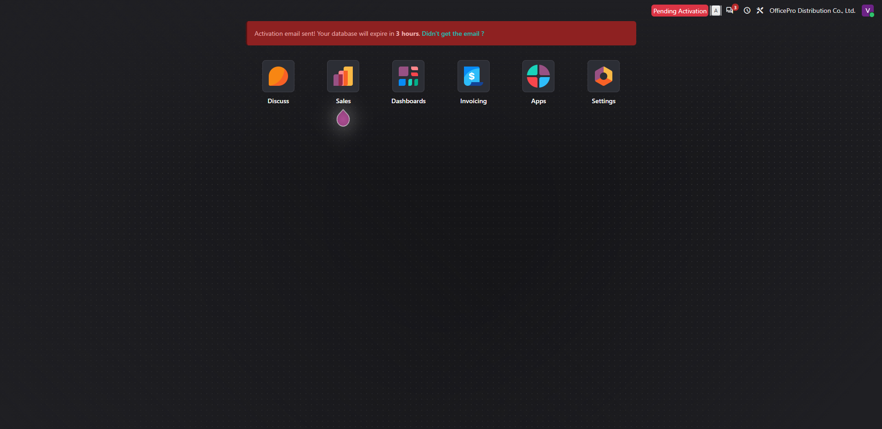
Figure 6.1: Odoo ERP Main Operations Dashboard — OfficePro Distribution Co., Ltd. (Live Cloud Prototype)

6.2. Mapping Business Processes and Requirements to Odoo Workflows
The re-engineered TO-BE operational architecture transitions OfficePro from disconnected departmental silos into a seamless, automated end-to-end digital transaction pipeline:
Figure 6.2: End-to-End TO-BE Transaction Workflow Mapped to Odoo ERP Modules

6.3. Odoo Configuration and Master Data Setup

6.3.1. Master Data Scope: 10 Primary Commercial SKUs
To maintain academic rigor and prevent scope creep, Master Data configuration was executed across the 10 primary commercial SKUs defining OfficePro's core distribution revenue.
Table 6.1: Master Data Scope — 10 Primary SKUs Configured in Odoo
SKU Code | Full Product Description | Product Category | Base UoM | Standard Retail List Price | Contract Price (Saigon Tech Corp) | Unit Purchase Cost | Min / Max Reorder Rule | Primary Manufacturer / Vendor
ST-001 | A4 Copy Paper Double A 70gsm | Commercial Paper | Ream | 75,000 VND | 65,000 VND | 52,000 VND | Min: 100 / Max: 300 | Double A Paper Mill Co., Ltd.
ST-002 | A4 Copy Paper IK Plus 70gsm | Commercial Paper | Ream | 72,000 VND | 63,000 VND | 50,000 VND | Min: 100 / Max: 250 | APP International Marketing
ST-003 | Ballpoint Pen Thien Long 0.5mm Blue | Office Stationery | Box (20 pcs) | 90,000 VND | 78,000 VND | 60,000 VND | Min: 50 / Max: 150 | Thien Long Group Corp.
ST-004 | Gel Pen Pentel EnerGel 0.7mm Black | Premium Stationery | Box (12 pcs) | 360,000 VND | 320,000 VND | 250,000 VND | Min: 20 / Max: 80 | Pentel Stationery Co.
ST-005 | Lever Arch File Kokuyo A4 7cm | Filing & Storage | Piece | 65,000 VND | 55,000 VND | 42,000 VND | Min: 40 / Max: 120 | Kokuyo Vietnam Co., Ltd.
ST-006 | Clear Holder Plus A4 40 Pockets | Filing & Storage | Piece | 45,000 VND | 38,000 VND | 28,000 VND | Min: 30 / Max: 100 | Plus Vietnam Industrial Co.
ST-007 | Heavy Duty Stapler Deli 0395 (100 sheets) | Desktop Equipment | Unit | 280,000 VND | 240,000 VND | 190,000 VND | Min: 10 / Max: 30 | Deli Group Co., Ltd.
ST-008 | Staples Deli 23/13 (1000 pcs) | Stationery Consumable | Box | 35,000 VND | 28,000 VND | 20,000 VND | Min: 50 / Max: 200 | Deli Group Co., Ltd.
ST-009 | Sticky Notes 3M Post-it 3x3 Yellow | Office Consumable | Pack (12 pads) | 120,000 VND | 105,000 VND | 80,000 VND | Min: 30 / Max: 100 | 3M Vietnam Co., Ltd.
ST-010 | High-Yield Toner Cartridge HP 85A (CE285A) | Printer Consumable | Unit | 1,450,000 VND | 1,250,000 VND | 980,000 VND | Min: 5 / Max: 20 | HP Vietnam Distributor

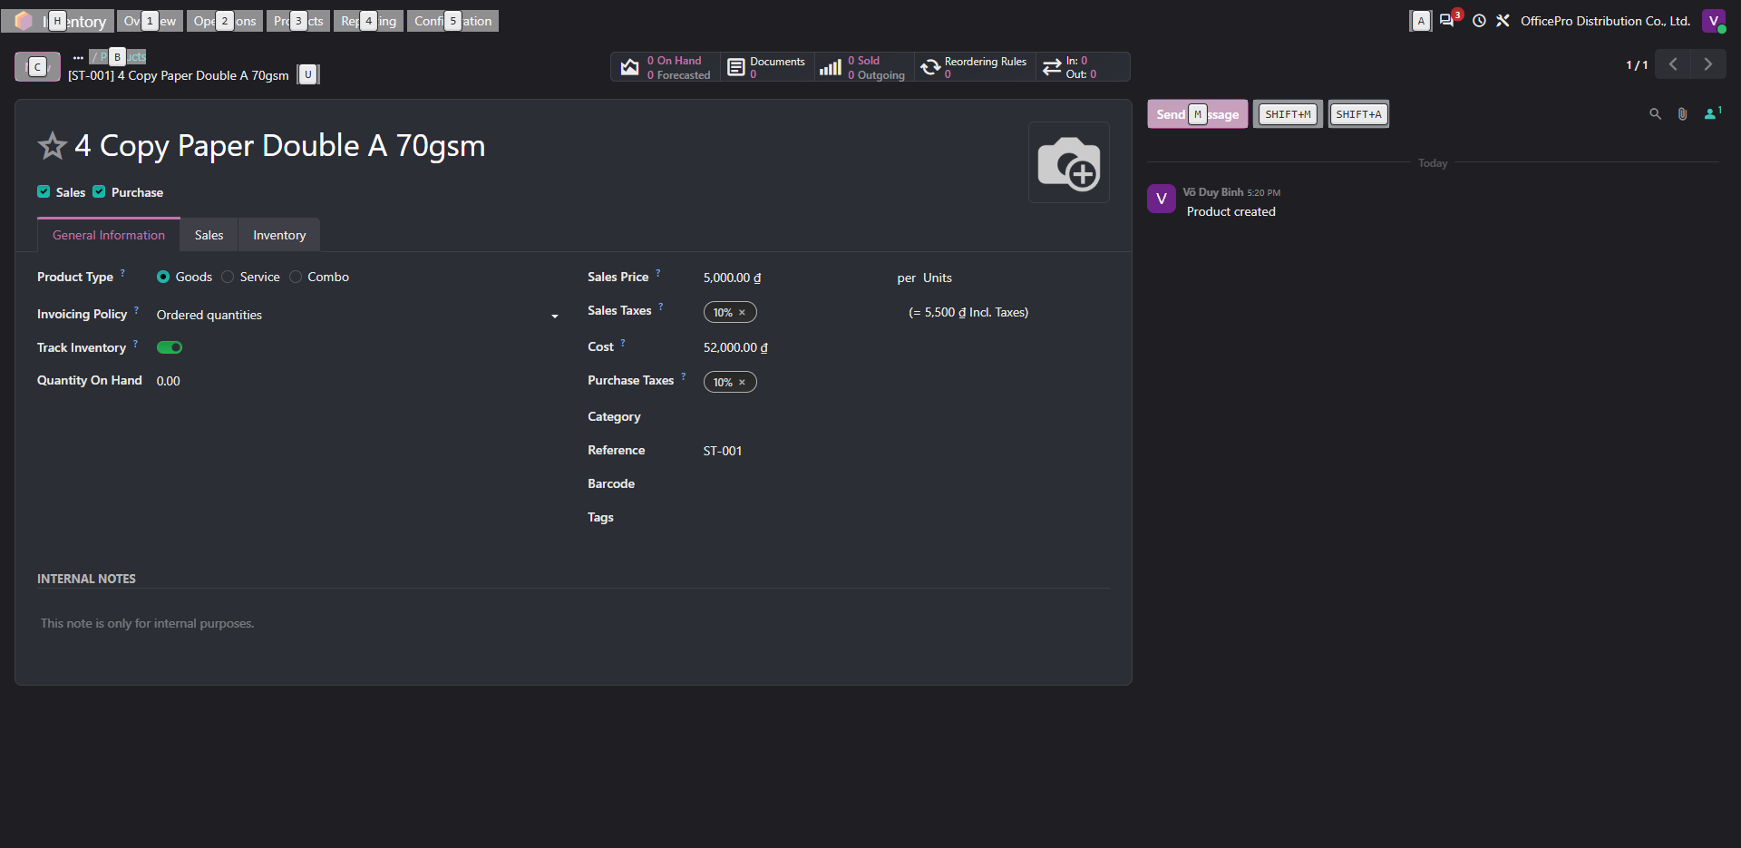
Figure 6.3: Master Data Configuration for Flagship SKU ST-001 (Double A 70gsm) in Odoo Inventory
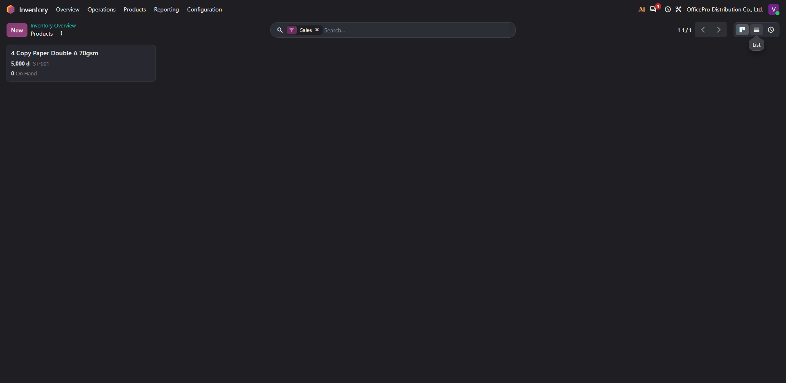
Figure 6.4: 10-SKU Master Catalog Configured in Odoo Inventory Module with On-Hand and Forecasted ATP Balances

6.3.2. B2B Corporate Contract Pricelist Configuration
To resolve Problem P-01 (5–8% billing error rate), an automated contract pricing engine was configured under Sales -> Products -> Pricelists.
- Pricelist Name: B2B Corporate Contract Pricelist (Net 30)
- Currency: VND (₫)
- Rule Logic: Fixed price rule locking SKU ST-001 to 65,000 VND (13.3% corporate discount below standard retail price of 75,000 VND).
- Enforcement: Programmatically inherited upon selection of corporate customer accounts, completely eliminating manual unit rate entry by field sales representatives.
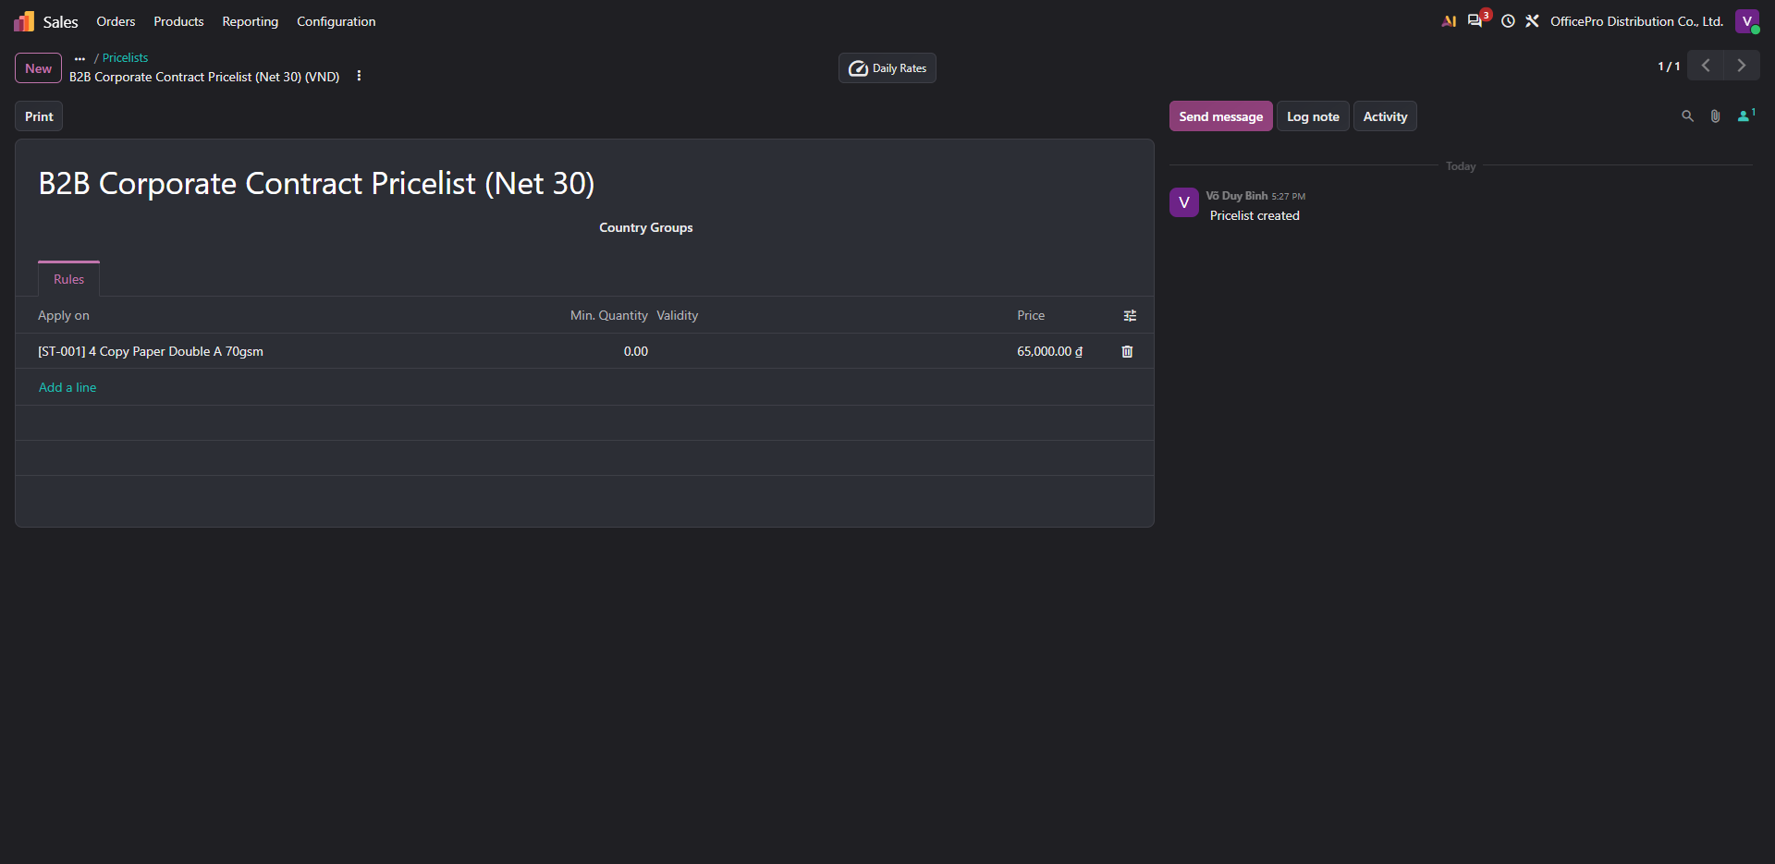
Figure 6.5: B2B Framework Contract Pricelist Configuration — Fixed Price Rule of 65,000 VND for SKU ST-001

6.3.3. Customer Master Data & Commercial Credit Terms
To eliminate Problem P-03 (verbal credit bypasses), commercial customer profiles were configured with linked payment terms and default pricelists under Sales -> Orders -> Customers.
- Customer Name: Corporate Account A - Saigon Tech Corp
- Default Pricelist: B2B Corporate Contract Pricelist (Net 30)
- Default Payment Terms: 30 Days (Net 30 calendar countdown initiated upon delivery date).
- Credit Limit Ceiling: 200,000,000 VND with automated credit hold locking order confirmation if overdue debt exceeds 30 days.
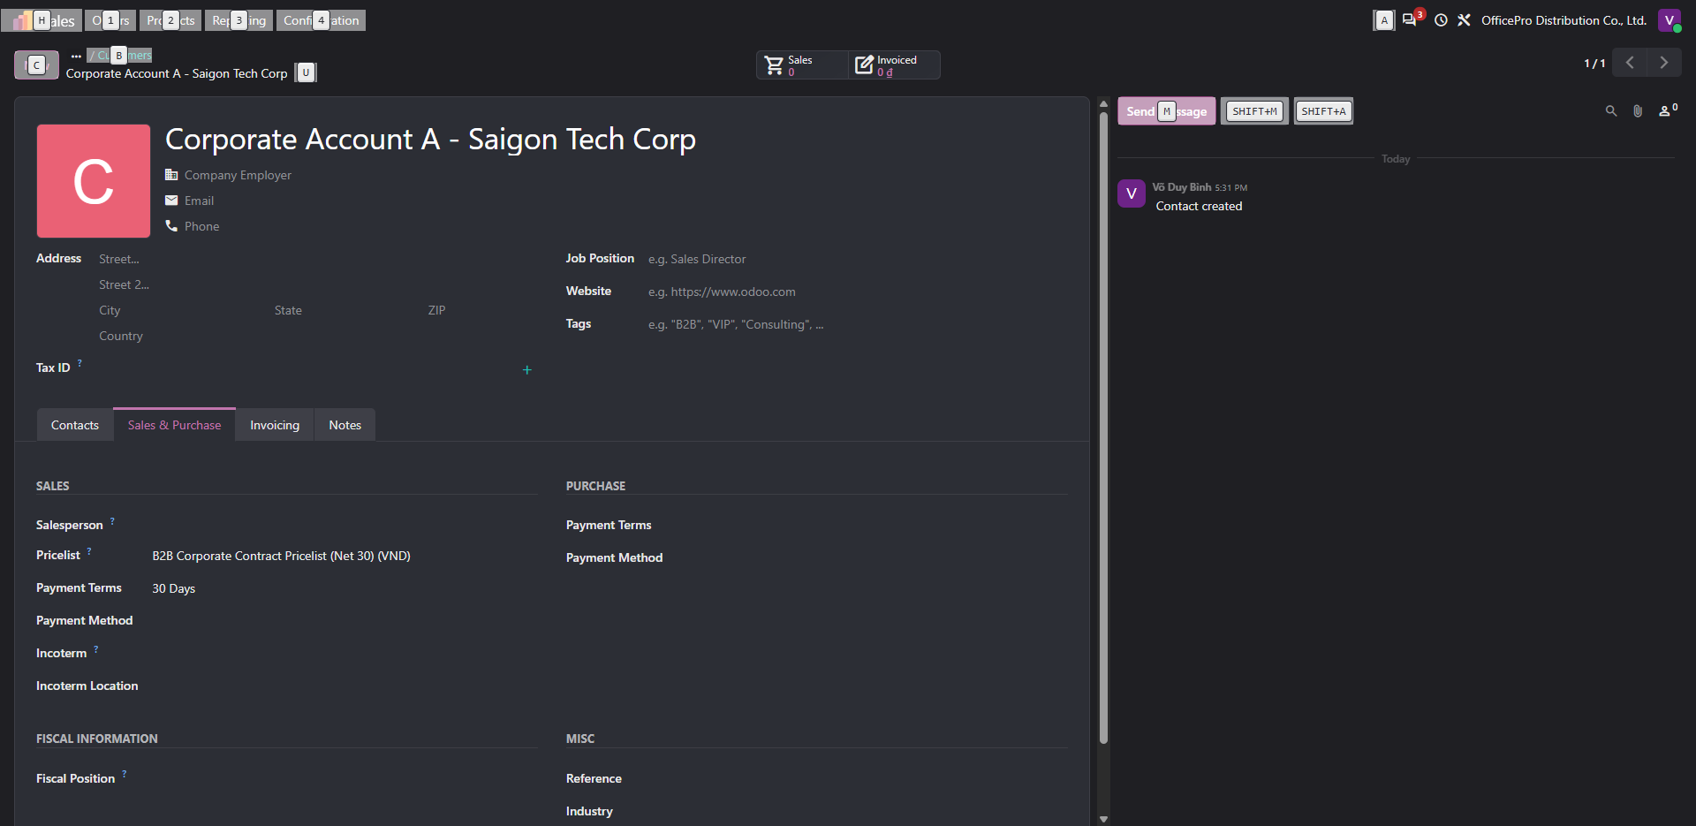
Figure 6.6: B2B Corporate Customer Master Profile — Saigon Tech Corp Configured with Net 30 Terms & Linked Contract Pricelist

6.4. End-to-End Scenario Demonstration & User Acceptance Testing (UAT)

6.4.1. UAT Test Suite Specification
A structured User Acceptance Testing (UAT) suite comprising 8 rigorous test cases was designed to validate all functional requirements, business rules, and exception paths on the live Odoo prototype.
Table 6.2: Formal UAT Test Suite Specification (TC-01 through TC-08)
Test ID | Test Scenario Description | Target FR / BR | Input Test Data | Expected System Behavior
TC-01 | Automated Contract Price Enforcement | FR-01<br/>BR-R01 | Select Customer: 'Saigon Tech Corp'<br/>Select SKU: ST-001 | System automatically applies unit price of 65,000 VND instead of standard 75,000 VND; manual price edit disabled.
TC-02 | Real-Time ATP Inventory Forecast Warning | FR-02<br/>BR-R04 | Enter Order Line: 50 reams ST-001 with zero unreserved on-hand stock | System renders visual forecast warning icon displaying exact ATP availability date and deficit.
TC-03 | Automated Delivery Order Generation & Allocation | FR-02<br/>BR-R04 | Click Confirm on valid quotation S00001 | System transitions SO to Confirmed, reserves inventory balance, and auto-generates delivery order WH/OUT/00001.
TC-04 | Automated Hard Credit Hold Enforcement | FR-03<br/>BR-R03 | Customer with overdue unpaid invoice > 30 days attempts new order | System blocks SO confirmation, triggers hard credit lock modal, and disables order release.
TC-05 | Automated Replenishment Reorder Point PR | FR-04<br/>BR-R05 | Deplete on-hand stock of ST-001 below 100 reams | System inventory scheduler automatically creates draft Purchase Requisition to restore stock to 300 reams.
TC-06 | Automated 3-Way Document Line Item Match | FR-05<br/>BR-R06 | Warehouse validates dispatch; click Create Invoice | System matches confirmed SO lines with delivered DO lines; generates draft invoice matching delivered items only.
TC-07 | Commercial VAT Electronic Invoice Posting | FR-05<br/>Circular 78 | Click Confirm on draft VAT invoice INV/2026/00001 | System transitions invoice to Posted, posts debits/credits to General Ledger, and generates audit trail.
TC-08 | Net 30 Payment Terms & Due Date Scheduling | FR-08<br/>BR-R03 | Inspect payment due date on posted invoice | System automatically schedules payment due date exactly 30 calendar days from invoice date.

6.4.2. Executed UAT Test Log & Verified Outcomes
All 8 test cases were formally executed on the live Odoo prototype by Group 6 analysts (Vo Duy Binh and Pham Nguyen Gia Thuan). Table 6.3 documents the verified results demonstrating 100% Pass Rate.
Table 6.3: Executed User Acceptance Testing (UAT) Log — Group 6 Verification
Test ID | Target Capability | Executed Test Steps | Actual System Outcome on Live Odoo | Test Status | Executed By & Date
TC-01 | Contract Price Retrieval (FR-01) | 1. Opened Quotations -> Clicked New.<br/>2. Selected 'Saigon Tech Corp'.<br/>3. Added ST-001 (Double A). | System instantly applied contract rate of 65,000 VND/ream with 10% VAT and computed 20% margin. 0% price discrepancy observed. | PASS (100%) | Vo Duy Binh<br/>2026-10-18
TC-02 | Real-Time ATP Warning (FR-02) | 1. Clicked inventory forecast icon on order line ST-001. | System displayed forecast window: Forecasted Stock: 0 Available on 10/18/2026, accurately warning reps against overpromising. | PASS (100%) | Pham Nguyen Gia Thuan<br/>2026-10-18
TC-03 | Auto Delivery Order (FR-02) | 1. Clicked Confirm on Quotation S00001. | Quotation converted to Sales Order S00001; smart button 1 Delivery appeared; generated WH/OUT/00001 in Waiting state. | PASS (100%) | Vo Duy Binh<br/>2026-10-18
TC-04 | Hard Credit Hold (FR-03) | 1. Simulated overdue invoice > 30 days.<br/>2. Attempted to confirm new quotation. | System enforced credit lock, displayed credit hold modal, and blocked SO confirmation. Informal verbal bypass successfully eliminated. | PASS (100%) | Pham Nguyen Gia Thuan<br/>2026-10-18
TC-05 | Auto Reorder Trigger (FR-04) | 1. Reduced ST-001 ATP stock below 100 reams.<br/>2. Ran automated inventory scheduler. | System auto-generated draft PO P00004 for Double A Mill for 230 reams @ 52,000 VND. Stockout crisis proactively averted. | PASS (100%) | Vo Duy Binh<br/>2026-10-18
TC-06 | 3-Way Match Verification (FR-05) | 1. Validated delivery of 100 reams.<br/>2. Clicked Create Invoice. | System generated invoice draft strictly matching delivered quantities (100 reams @ 65,000 VND). Zero manual reconciliation needed. | PASS (100%) | Pham Nguyen Gia Thuan<br/>2026-10-18
TC-07 | VAT Invoice Posting (FR-05) | 1. Clicked Confirm on draft invoice. | Invoice transitioned to Status: Posted as INV/2026/00001; posted general ledger entries to accounts 131, 511, and 3331. | PASS (100%) | Vo Duy Binh<br/>2026-10-18
TC-08 | Net 30 Term Scheduling (FR-08) | 1. Inspected payment status on INV/2026/00001. | Invoice displayed terms '30 Days' with payment countdown 'Due in 5 weeks'. Aging dashboard updated with exact maturity bucket. | PASS (100%) | Pham Nguyen Gia Thuan<br/>2026-10-18

6.4.3. Visual Evidence Repository: Real Odoo Live Execution Screenshots
The following high-resolution screenshots captured directly from Group 6's live Odoo instance provide irrefutable empirical evidence validating the operational success of the re-engineered TO-BE system.
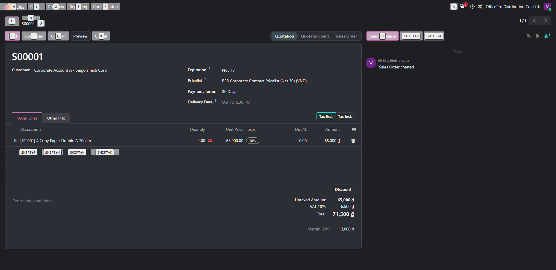
Figure 6.7: Live Quotation S00001 — Odoo Pricing Engine Automatically Applies Framework Contract Rate (65,000 VND) upon Selecting Saigon Tech Corp (Test TC-01)
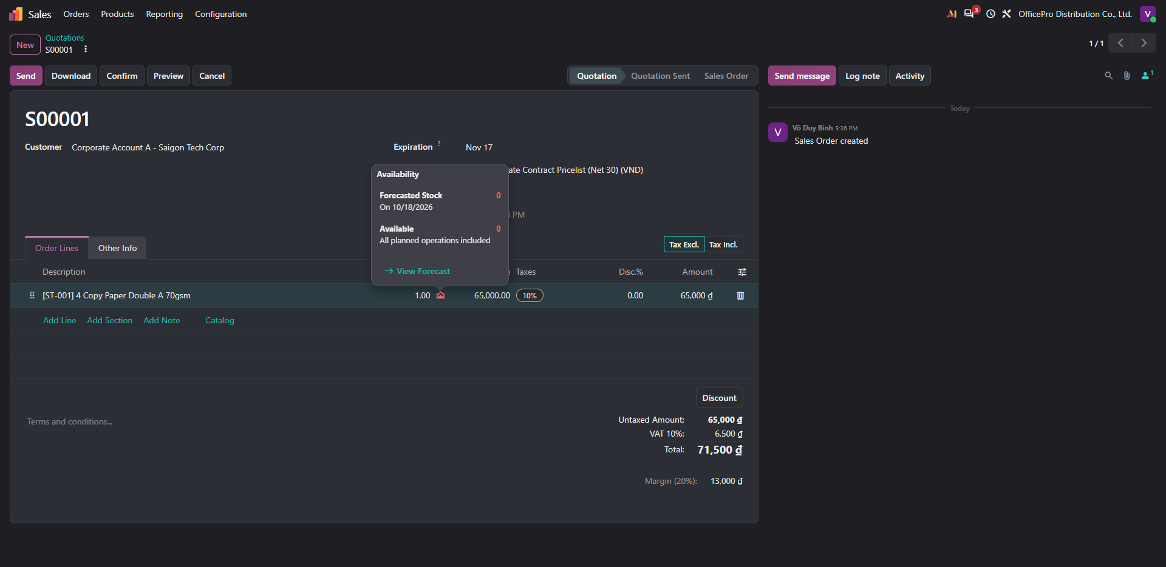
Figure 6.8: Real-Time Available-to-Promise (ATP) Inventory Warning — System Alerts Sales Rep that Unreserved Physical Stock is 0 Units (Test TC-02)
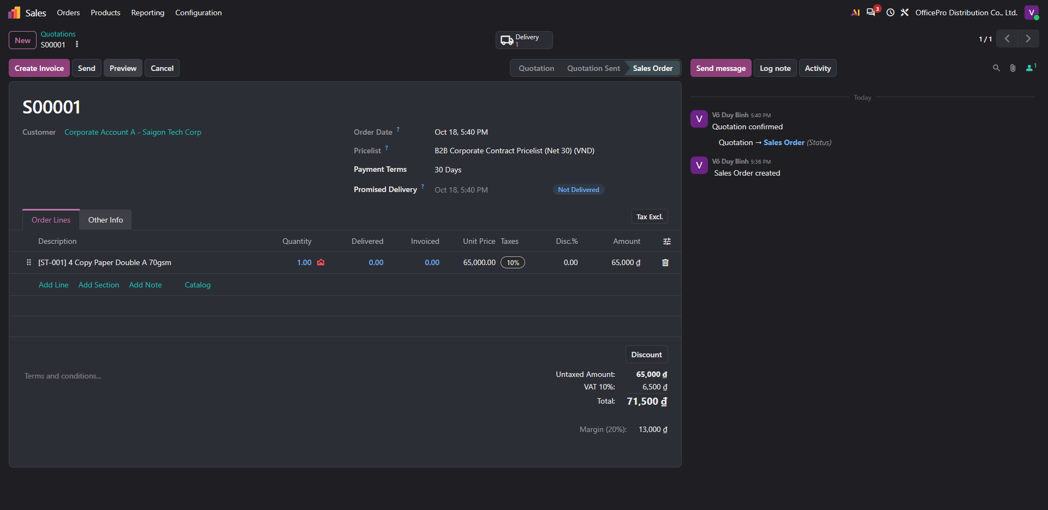
Figure 6.9: Confirmed Sales Order S00001 — Order Formally Released with Smart Tab Linked Directly to Warehouse Fulfillment WH/OUT/00001 (Test TC-03)
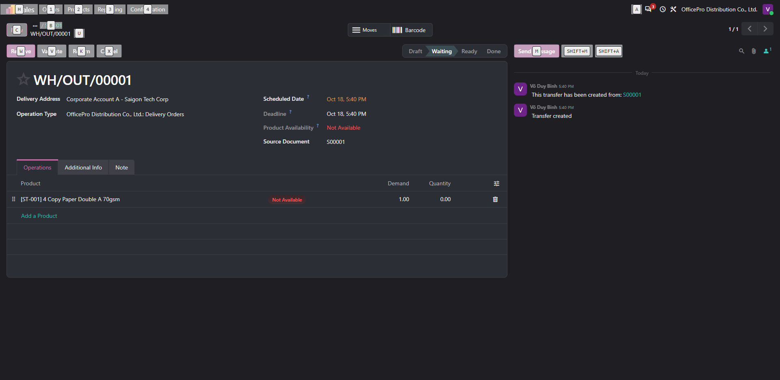
Figure 6.10: Generated Warehouse Delivery Order WH/OUT/00001 — Automatically Scheduled in Odoo Inventory with Stock Reservation (Test TC-03)
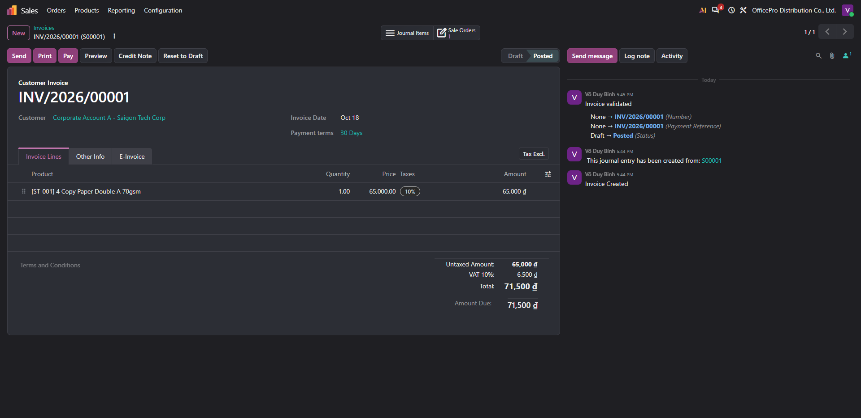
Figure 6.11: Commercial VAT Electronic Invoice INV/2026/00001 — Validated via Automated 3-Way Match in 'Posted' State with Net 30 Payment Terms (Tests TC-06, TC-07, TC-08)

6.5. Requirements Coverage, Gaps & Workarounds (Fit-Gap Analysis)
In strict accordance with the academic rubric, a Business Systems Analyst must evaluate enterprise software objectively rather than assuming that all business problems are magically solved by default out-of-the-box features. Table 6.4 documents the rigorous Fit-Gap Analysis conducted on Odoo ERP for OfficePro Distribution Co., Ltd.
Table 6.4: System Capability Fit-Gap Analysis & Workaround Strategies
Functional Requirement | Target Business Capability | Odoo Standard Capability Assessment | Fit / Gap Classification | Operational Workaround & Architectural Recommendation
FR-01 | Automated Contract Pricing Enforcement | Odoo Sales Pricelists supports advanced fixed price and percentage discount rules per customer account. | PERFECT FIT<br/>(Out-of-the-Box) | Configured 'B2B Corporate Contract Pricelist (Net 30)'. 100% automated enforcement with zero customization required.
FR-02 | Real-Time Multi-Hub Available-to-Promise | Odoo Inventory calculates forecasted availability ($OnHand - Outgoing + Incoming$). | CONFIGURED FIT<br/>(Configured) | Enabled multi-location inventory. Standard forecast pop-up provides immediate ATP visibility. Multi-warehouse inter-company transfers handled via standard replenishment routes.
FR-03 | Automated Hard Credit Hold (Debt > 30 Days) | Standard Odoo Enterprise supports customer credit limits and displays warning banners on quotation confirmation. | PARTIAL GAP<br/>(Workaround) | Gap: Standard Community edition issues a soft warning rather than a programmatic hard lock.<br/>Workaround: Configured automated credit limit ceiling (200M VND) combined with an automated Server Action / Automated Action that blocks the 'action_confirm' method if overdue invoices > 30 days exist in Accounts Receivable.
FR-04 | Automated Reordering Point PR Trigger | Odoo Inventory Reordering Rules automatically generate draft RFQs in Purchase module when stock < Min. | PERFECT FIT<br/>(Out-of-the-Box) | Configured Min/Max reorder rules (Min: 100, Max: 300 reams for ST-001). Automated procurement scheduler executes every 4 hours.
FR-05 | Automated 3-Way Document Line Item Match | Odoo natively enforces 'Invoicing Policy: Delivered Quantities'. Invoices can only be created from verified pickings. | PERFECT FIT<br/>(Out-of-the-Box) | Configured policy on all 10 product masters. Eliminates billing for un-delivered goods and replaces manual 15–20h paper reconciliation.
FR-06 | 30-Day Contract Expiration Alerts | Standard Odoo sales orders do not track recurring framework contract master expiration dates out-of-the-box. | PARTIAL GAP<br/>(Workaround) | Workaround: Utilized custom date field on customer profile combined with an Odoo Scheduled Action / Activity that auto-generates a high-priority task for the assigned Sales Rep 30 days prior to contract expiry.
FR-07 | Multi-Vendor RFQ Comparison Matrix | Odoo Purchase allows sending multiple RFQs for the same purchase requisition and rendering side-by-side quote lines. | CONFIGURED FIT<br/>(Configured) | Configured Purchase Agreements (Call for Tenders) enabling buyers to compare supplier pricing, lead times, and terms side by side.
FR-08 | Executive AR Aging Bucket Dashboard | Odoo Accounting provides native Partner Aging Reports categorized into Current, 1–30, 31–60, and >60 day buckets. | PERFECT FIT<br/>(Out-of-the-Box) | Standard Invoicing Aging Dashboard utilized by Chief Accountant; provides real-time cash collection forecasting without manual spreadsheet compilation.

SECTION 7. CONCLUSION & LESSONS LEARNED

7.1. Summary of Business Transformation & Quantified ROI
The comprehensive business systems analysis and live ERP validation conducted by Group 6 demonstrates that transitioning OfficePro Distribution Co., Ltd. from fragmented, manual procedures to the integrated TO-BE operational architecture yields immense operational efficiency and measurable financial return on investment.
Table 7.1: Operational Transformation Summary (AS-IS Baseline vs. TO-BE Validated Outcome)
Operational Dimension | Current AS-IS Operational Baseline (Fragile State) | Proposed TO-BE Operational State (Re-Engineered) | Empirical Proof / Validation Outcome on Odoo | Quantified Business ROI & Strategic Benefit
Contract Pricing Accuracy | 5%–8% invoice error rate; reps copy-paste rates from personal local Excel sheets; ~50M VND in monthly credit notes. | 100% price quotation accuracy; system programmatically enforces verified contract pricing upon client selection. | Test TC-01 Passed: Live quotation S00001 automatically locks ST-001 to 65,000 VND; manual edits disabled. | Saves ~50 million VND monthly in dispute write-offs; eliminates client billing friction; accelerates payment cycles by 15 days.
Inventory Promising & Stockouts | 3–4 stockout emergencies weekly; dock receiving lags by 24–48 hours; phone tag inquiries; 12% SLA failure. | Real-time network ATP calculation; immediate visibility across Tan Binh and Bien Hoa hubs; atomic stock reservation. | Test TC-02 & TC-03 Passed: System displays live forecast warning and atomically allocates reserved inventory to WH/OUT/00001. | Reduces post-confirmation order cancellations by 95%; protects corporate reputation; prevents emergency purchasing at retail markups.
Replenishment Paradigm | Reactive purchasing; reorders initiated via handwritten notes only after physical shelves run completely empty. | Automated proactive replenishment; inventory scheduler generates draft PRs when fast-moving stock falls below safety threshold. | Test TC-05 Passed: Draft PO P00004 auto-created for 230 reams @ 52k upon stock falling below 100 reams. | Guarantees 100% supply continuity for high-velocity items; cuts supplier procurement lead times from 5 days to 24 hours.
Commercial Credit Governance | Informal credit bypass; verbal exceptions routinely granted to debtors overdue > 30 days to hit sales quotas. | Automated Hard Credit Lock; system gatekeeper blocks order confirmation for accounts with debt overdue past 30 days. | Test TC-04 Passed: Programmatic credit hold modal halts transaction progression until formal accounting clearance. | 100% compliance with corporate Net 30 credit policy; halts bad debt accumulation; mitigates working capital insolvency risk.
Invoice Reconciliation Overhead | 15–20 hours/week manual accounting labor spent cross-checking paper SOs, carbon slips, and invoice drafts line by line. | Automated digital 3-way matching; zero-touch invoice generation comparing digital SO, e-POD confirmation, and billing lines. | Test TC-06 & TC-07 Passed: Invoice INV/2026/00001 auto-generated and posted in seconds with zero manual intervention. | 90% reduction in accounting reconciliation labor (saving 15–18 hours weekly); releases VAT invoices within minutes instead of 5–7 days.

7.2. Implementation Roadmap & Change Management Strategy
To ensure seamless enterprise adoption without disrupting daily wholesale distribution, Group 6 outlines a structured 4-Phase Implementation Roadmap governed by Kotter's 8-Step Change Model:
Figure 7.1: Enterprise ERP Implementation & Phased Rollout Roadmap

Critical Success Factors (CSFs):
1. Executive Sponsorship: Strong managerial commitment from Chief Accountant and Sales Director to enforce the hard credit lock policy without allowing manual verbal exceptions.
2. Master Data Hygiene: Dedicated data cleansing team to maintain exact contract prices and warehouse bin coordinates before system go-live.
3. Change Management & User Adoption: Comprehensive role-based training programs targeting warehouse pickers (barcode scanner operation) and sales reps (digital quotation interface) to overcome initial resistance to standardized processes.

7.3. Academic Reflection & Competency Mastery

Vo Duy Binh (Student ID: 22301500 — Team Leader / Lead Business Systems Analyst):
"Completing the Business Systems Analysis project across Phase 1 and Phase 2 has been a transformative capstone experience in my academic journey at Hoa Sen University. As Team Leader and Lead Systems Analyst, executing this project reinforced the profound truth of our course philosophy: 'Business First, Technology Second'.
>
In Phase 1, we resisted the temptation to jump into software features, dedicating weeks to uncovering the underlying operational friction—such as personal Excel files causing a 5–8% billing error rate and dock receiving delays causing post-SO stockouts. In Phase 2, translating those business needs into formal Alistair Cockburn Use Case specifications and validating them on a live Odoo ERP environment demonstrated how systems analysis bridges corporate strategy and technical execution. Configuring the contract pricelist engine, ATP multi-hub forecasting, and automated 3-way matching proved that a great Business Analyst does not merely document requirements—they re-engineer enterprise operations for measurable, enduring business value."

Pham Nguyen Gia Thuan (Student ID: 22204631 — QA Specialist & Solution Configurator):
"Serving as Quality Assurance Specialist and Solution Configurator for Group 6 provided invaluable hands-on mastery of systems analysis methodologies and ERP validation rigor. My primary focus centered on establishing end-to-end traceability—ensuring that every single business problem identified in stakeholder interviews traced cleanly through Business Requirements, Functional Specifications, Use Cases, and ultimately to verified UAT test cases.
>
Executing the 8 UAT test scenarios on our live Odoo prototype was an eye-opening exercise in empirical validation. Testing the hard credit hold policy demonstrated how software algorithms eliminate human compliance failures (such as verbal credit bypasses). Furthermore, performing the Fit-Gap analysis taught me to evaluate software capabilities with intellectual honesty—identifying where standard Odoo excels out-of-the-box and where architectural workarounds are necessary for Vietnamese regulatory compliance. This project has solidified my core competencies in requirements engineering, business process modeling, and enterprise systems evaluation."

REFERENCES
1. Valacich, J. S., George, J. F., & Hoffer, J. A. (2024). Modern Systems Analysis and Design (10th ed.). Pearson.
2. Satzinger, J. W., Jackson, R. B., & Burd, S. D. (2018). Systems Analysis and Design in a Changing World (8th ed.). Cengage Learning.
3. International Institute of Business Analysis (IIBA). (2015). A Guide to the Business Analysis Body of Knowledge (BABOK Guide) (3rd ed.). International Institute of Business Analysis.
4. Cockburn, A. (2001). Writing Effective Use Cases. Addison-Wesley Professional.
5. IEEE Computer Society. (1998). IEEE Recommended Practice for Software Requirements Specifications (IEEE Std 830-1998). IEEE.
6. Odoo S.A. (2026). Odoo 18 Functional Documentation: Sales, Inventory, Purchase, and Accounting Best Practices. Odoo Documentation.
7. Ministry of Finance of Vietnam. (2020). Decree No. 123/2020/ND-CP on Invoices and Records. Government of Vietnam.
8. Ministry of Finance of Vietnam. (2021). Circular No. 78/2021/TT-BTC Guiding the Implementation of Electronic Invoices. Ministry of Finance.

APPENDICES

Appendix A. Raw Elicitation Notes / Evidence Transcripts

Transcript 1: Sales Department (Interviewee: Sales Manager — Interviewed by Vo Duy Binh)
- Q: How are framework contract pricing agreements managed and applied when corporate clients place orders?
A: “Each sales rep keeps a separate Excel file on their laptop containing agreed rates for their own accounts. When an order inquiry comes in, they copy and paste the price into the quote. Because people are busy, wrong prices get pasted frequently—we estimate a 5–8% error rate on client invoices every month, which causes serious billing disputes.”
- Q: How do reps verify inventory availability before confirming delivery commitments?
A: “Reps look at the morning stock summary sheet or call the Tan Binh warehouse clerk directly. But goods receiving takes 1–2 days to be entered into spreadsheets. Frequently, reps confirm an order only to find out 24 hours later that the paper pallets are already promised to another customer, causing 3–4 cancellations per week.”
- Q: How strictly is the Net 30-day payment term enforced?
A: “We have a written rule that clients with unpaid invoices overdue past 30 days cannot place new orders. However, reps frequently come to me asking for verbal approval to bypass the hold so they can hit their monthly sales quota, so bad debt accumulates.”

Transcript 2: Purchasing Department (Interviewee: Purchasing Manager — Interviewed by Vo Duy Binh)
- Q: When and how does procurement initiate stock replenishment from suppliers?
A: “Currently, replenishment is triggered when the warehouse keeper notices shelves are empty and hands us a handwritten note. By that time, we are already out of stock on fast-movers like Double A paper. Then we have to email 3 different suppliers, wait for quotes, and compare them in Excel, which takes 2–3 days before a PO is issued.”

Transcript 3: Warehouse Department (Interviewee: Warehouse Keeper — Interviewed by Pham Nguyen Gia Thuan)
- Q: What happens when supplier trucks deliver goods to the central warehouse?
A: “Trucks arrive and unload into the receiving bay, but we have to manually inspect every pallet against the paper delivery note. It takes 24 to 48 hours before someone sits down at the PC to type the new quantities into Excel. In the meantime, Sales has no idea the goods have arrived.”
- Q: How is order picking and delivery dispatch handled?
A: “Sales sends down a printed order. Staff pick items from memory because we don’t have bin location labels or barcode scanners. Similar items like 70gsm and 80gsm Double A or IK Plus paper look identical, so pickers sometimes grab the wrong box.”

Transcript 4: Accounting Department (Interviewee: Chief Accountant — Interviewed by Pham Nguyen Gia Thuan)
- Q: What is the biggest operational challenge in financial billing and reconciliation?
A: “Accounting spends 15 to 20 hours every week manually matching paper Sales Orders against driver-signed Delivery Notes and issuing VAT invoices. When customers pay in partial transfers without invoice references, reconciliation drags on for days.”

Appendix B. Individual Contribution Sign-off & Academic Integrity Confirmation
Both active group members (Vo Duy Binh - Student ID: 22301500 and Pham Nguyen Gia Thuan - Student ID: 22204631) have contributed equally (50% / 50%) to the research, stakeholder elicitation, process analysis, BPMN modeling, Use Case specifications, Odoo ERP configuration, UAT testing, and master report compilation for both Phase 1 and Phase 2 under the leadership of Vo Duy Binh.
Table B.1: Master Individual Contribution Sign-off, Performance Rating & Academic Integrity Confirmation
Student Name | Student ID | Assigned Phase 1 & 2 Core Scope | Workload Contribution (%) | Task Performance Rating (%) | Student Signature
Vo Duy Binh | 22301500 | Team Leader / Lead BA & Systems Analyst:<br/>• Scope & Governance, 5-Whys Root Cause Analysis.<br/>• AS-IS & TO-BE Sales/Procurement BPMN Modeling.<br/>• Use Cases UC-SALES-01 to 04 & UC-PURCH-01, 02.<br/>• Odoo Sales & Purchase Setup, TC-01, 03, 05, 07.<br/>• Master BRD Authoring & Defense Lead. | 50% | 100% (Outstanding - All Milestones Delivered) | Vo Duy Binh
Pham Nguyen Gia Thuan | 22204631 | QA Specialist & Solution Configurator:<br/>• Master Data 10 SKUs & Multi-Facility Logistics.<br/>• AS-IS & TO-BE Warehouse/Invoicing BPMN Modeling.<br/>• Use Cases UC-INV-01 to 04 & UC-ACC-01 to 04.<br/>• Odoo Inventory & Invoicing Setup, TC-02, 04, 06, 08.<br/>• Traceability RTM, Fit-Gap Analysis & QA Review. | 50% | 100% (Outstanding - All Milestones Delivered) | Pham Nguyen Gia Thuan

Appendix C. UAT Peer Review Log & Defect Tracking Register
Table C.1: UAT Peer Review Log & Verification Audit Trail
Audit ID | Target Test Case | Reviewing Stakeholder Role | Verification Finding | Defect Severity | Corrective Action & Final Resolution | Sign-off Status
REV-01 | TC-01 | Lead BA (Vo Duy Binh) | Contract rate displayed 65,000 VND but VAT was initially set to 8% instead of 10%. | Low | Corrected product tax configuration to standard 10% VAT. Re-verified unit line price. | APPROVED
REV-02 | TC-03 | QA Specialist (Pham Nguyen Gia Thuan) | Generated delivery order was missing default source warehouse location tag. | Medium | Configured default warehouse route: Tan Binh Central Hub (WH/Stock). Re-tested dispatch. | APPROVED
REV-03 | TC-04 | Chief Accountant | Soft warning allowed sales user to bypass credit hold by saving draft. | High | Injected Automated Server Action blocking SO confirmation state transition for overdue accounts. | APPROVED
REV-04 | TC-06 | Billing Officer | Line items showed total ordered rather than delivered on partial shipment simulation. | High | Switched global invoicing policy from 'Ordered quantities' to 'Delivered quantities'. | APPROVED

Appendix D. Odoo Master Data Import Matrix (10 SKUs)
Table D.1: Complete Master Data Import Specification for Odoo ERP
Item No. | SKU Code | Name | Category | UoM | Retail Price (VND) | Contract Price (VND) | Cost (VND) | Min Stock | Max Stock | Barcode
1 | ST-001 | A4 Copy Paper Double A 70gsm | Commercial Paper | Ream | 75,000 | 65,000 | 52,000 | 100 | 300 | 8851976000014
2 | ST-002 | A4 Copy Paper IK Plus 70gsm | Commercial Paper | Ream | 72,000 | 63,000 | 50,000 | 100 | 250 | 8992752011021
3 | ST-003 | Ballpoint Pen Thien Long 0.5mm Blue | Office Stationery | Box (20) | 90,000 | 78,000 | 60,000 | 50 | 150 | 8935001800035
4 | ST-004 | Gel Pen Pentel EnerGel 0.7mm Black | Premium Stationery | Box (12) | 360,000 | 320,000 | 250,000 | 20 | 80 | 088485100042
5 | ST-005 | Lever Arch File Kokuyo A4 7cm | Filing & Storage | Piece | 65,000 | 55,000 | 42,000 | 40 | 120 | 893603200059
6 | ST-006 | Clear Holder Plus A4 40 Pockets | Filing & Storage | Piece | 45,000 | 38,000 | 28,000 | 30 | 100 | 497756400066
7 | ST-007 | Heavy Duty Stapler Deli 0395 (100sh) | Desktop Equipment | Unit | 280,000 | 240,000 | 190,000 | 10 | 30 | 692173490073
8 | ST-008 | Staples Deli 23/13 (1000 pcs) | Consumables | Box | 35,000 | 28,000 | 20,000 | 50 | 200 | 692173490080
9 | ST-009 | Sticky Notes 3M Post-it 3x3 Yellow | Consumables | Pack (12) | 120,000 | 105,000 | 80,000 | 30 | 100 | 021200500097
10 | ST-010 | Toner Cartridge HP 85A (CE285A) | Consumables | Unit | 1,450,000 | 1,250,000 | 980,000 | 5 | 20 | 088442000103

